|  |  |  |  |  |
| --- | --- | --- | --- | --- |
|  |  | | |  |
|  |  | | |  |
|  | Power Running Boards  <<Feature>>  (F000166) | | |  |
|  |  | | |  |
| Document Type | **Feature Document (FD)** | | |  |
| Template Version | **6.1b** | | |  |
| SysML Report Template Version | **6.1b.2** | | |  |
| Document ID | **featuredocument_sysmlreport_6.1b.2.docx** | | |  |
| Document Location |  | | |  |
| Document Owner | **Angel Vargas - Feature Owner**  **Elia Cardoso - Feature Owner** | | |  |
| Document Revision | **FD1** | | |  |
| Document Status | **Draft** | | |  |
| Date Issued | **2022/02/03** | | |  |
| Date Revised | **2022/02/03** | | |  |
| Document Classification | GIS1 Item Number: | **27.60/35** | |  |
| GIS2 Classification: | **Confidential** | |
|  | | | | |
|  | | | | |
| Document Approval | | | | |
| Person | Role | | Email Confirmation | Date |
|  |  | |  |  |
|  |  | |  |  |

**Auto-Generated by MagicDraw**

Printed Copies Are Uncontrolled

# Disclaimer

**This document contains Ford Motor Company Confidential information. Disclosure of the information contained in any portion of this document is not permitted without the expressed, written consent of a duly authorized representative of Ford Motor Company, Dearborn, Michigan, U.S.A.**

**Copyright, Ó 2021 Ford Motor Company**

This document contains information developed and accumulated by and for FORD MOTOR COMPANY. As such, it is a proprietary document, which, if disseminated to unauthorized persons, would provide others with restricted information, data, or procedures not otherwise available, exposing the FORD MOTOR COMPANY to potential harm.

Employees and suppliers having custody of this specification or authorized to use it must be cognizant of its proprietary nature and ensure that the information herein is not made available to unauthorized persons.

FORD MOTOR COMPANY reserves the right to protect this work as an unpublished copyrighted work in the event of an inadvertent or deliberate unauthorized publication. FORD MOTOR COMPANY also reserves its rights under copyright laws to protect this work as a published work.

This document or portions thereof shall not be distributed outside FORD MOTOR COMPANY without prior written consent. Refer all questions concerning disclosure to the author(s) or to any duly authorized representative of Ford Motor Company.

**Copyright** © **2021 Ford Motor Company**

# Contents

Disclaimer 2

Contents 3

1 Introduction 6

1.1 Document Purpose 6

1.2 Document Scope 6

1.3 Document Audience 6

1.3.1 Stakeholder List 6

1.4 Document Organization 8

1.4.1 Document Context 8

1.4.2 Document Structure 8

1.5 Document Conventions 8

1.5.1 Classification of Chapters 8

1.5.2 Requirements Templates 8

1.6 References 9

1.6.1 Ford Documents 9

1.6.2 External Documents and Publications 10

1.7 Glossary 11

1.7.1 Definitions 11

1.7.2 Abbreviations 11

1.7.3 Parameters / Values 11

2 Feature Overview 12

2.1 Purpose and Description of Feature 12

2.2 Feature Variants 13

2.2.1 Regions & Markets 14

2.3 Input Requirements/Documents 14

2.4 Lessons Learned 15

2.5 Assumptions 15

3 Feature Context 16

3.1 Feature Context Diagram 16

3.2 List of Influences 16

4 Feature Modeling 18

4.1 Operation Modes and States 18

4.2 Use Cases 20

4.2.1 Use Case Diagram 20

4.2.2 Actors 21

4.2.3 Use Case Descriptions 21

4.3 Driving and Operation Scenarios 24

4.4 Decision Tables 36

5 Feature Requirements 37

5.1 Functional Requirements 37

5.1.1 Error Handling 49

5.2 Non-Functional Requirements 49

5.2.1 Security 49

5.2.2 Reliability 49

5.2.3 Performance 49

5.3 HMI Requirements 49

5.4 Other Requirements 52

5.4.1 Design Requirements 52

5.4.2 Manufacturing Requirements 52

5.4.3 Service Requirements 53

5.4.4 After Sales Requirements 54

5.4.5 Process Requirements 54

6 Functional Safety 55

6.1 System Behaviors for HARA 55

6.2 Functional Safety Assumptions 55

6.3 Safety Goals 55

6.4 Functional Safety Requirements 56

6.4.1 Safety Goal: Prevent Hazard (Example) 56

6.4.2 Derivation of Functional Safety Requirements on Assumptions 57

6.4.3 ASIL Decomposition of Functional Safety Requirements 57

7 CyberSecurity 59

7.1 Security Goals 59

7.2 Cybersecurity Requirements 59

8 Architecture 60

8.1 Functional Decomposition 60

8.1.1 Functions 63

8.2 Logical Architecture 63

8.2.1 Logical Elements 64

8.2.2 Logical Interfaces 65

9 Traceability Matrix 69

10 Open Concerns 70

11 Revision History 71

12 Appendix 72

12.1 Definitions 72

12.2 Abbreviations 72

**List of Figures**

Figure 2: Feature Image Here 13

Figure 4: Feature Context 16

Figure 5: Power Running Boards_Logical 18

Figure 6: Feature 21

Figure 8: Deploy running boards 25

Figure 8: Functional Boundary Behavior 27

Figure 7: SC_FNC_00001 27

Figure 8: SC_FNC_00001 28

Figure 8: SC_FNC_00002 29

Figure 8: SC_FNC_00003 31

Figure 8: SC_FNC_00004 33

Figure 8: Stow Running Boards 35

Figure 9: W&RC #1 Diagram – Prevent Hazard (Example) 57

Figure 10: Functional Boundary Behavior 62

Figure 11: Logical 64

**List of Tables**

Table 1: Features described in this FD 6

Table 2: Stakeholder’s list 7

Table 3: Ford internal Documents 10

Table 4: External documents and publications 11

Table 5: Parameters / Values used in this document 11

Table 6: Feature Variants 14

Table 7: Regions & Markets 14

Table 8: Input Requirements/Documents 14

Table 9: List of Influences 17

Table 10: Operation Modes and States on Power Running Boards_Logical 19

Table 11: Transitions between Operation Modes and States on Power Running Boards_Logical 20

Table 12: List of Actors 21

Table 14: System Behaviors for HARA 55

Table 15: Functional Safety Assumptions 55

Table 16: Functional Safety Goals 56

Table 17: Cybersecurity Goals 59

Table 18: List of Functions 63

Table 20: Logical Elements 65

Table 21: Feature Interactions 68

Table 23: Open Concerns *(Not supported by MagicDraw report generation)* 70

Table 25: Definitions used in this document 72

Table 26: Abbreviations used in this document 73

# Introduction

## Document Purpose

A Feature Document (FD) document defines a Feature on [Concept Level](https://bd101001.pd2.ford.com/stages/#/workspace/209/_vv/(process/activity/_Y6ftAPI2VsW5zd82DgHb6g)). It specifies **what** the feature shall do and how it shall behave from customer perspective. It should also provide reasoning and background **why** we have the feature in the vehicle.

The FD also serves as an Item Definition as defined by ISO26262 for those features, which follow the Ford Functional Safety process. Refer [FFSG01.10 Feature Document Guideline](https://azureford.sharepoint.com/sites/GlobalFunctionalSafety/Released%20Templates%20Guidelines%20and%20Examples/Guidelines/FFSG01.10_FeatureDocument_Guideline.pdf) for how to apply the Feature Doc template for Functional Safety.

## Document Scope

This Feature Document (FD) specifies the following features:

| **Feature ID** | **Feature Name** | **Owner** | **Reference** |
| --- | --- | --- | --- |
| F000166 | Power Running Boards  (Program(s): P702 MY 2024 MCA ICE.FHEV) | Angel Vargas - Feature Owner  Elia Cardoso - Feature Owner |  |

Table 1: Features described in this FD

## Document Audience

The FD is written by the feature owner of Power Running Boards. All Stakeholders, i.e., all people who have a valid interest in the feature should read and, if possible, review the FD. It needs to be guaranteed, that all stakeholders have access to the currently valid version of the FD.

**#Hint:** The FD template has the IP Classification “Proprietary” by default. IP Classification “Confidential” might be required in some cases, e.g. by Ford Functional Safety.

**#Macro:** [Add Ins -> Edit Document Properties macro](https://wiki.ford.com/pages/viewpage.action?pageId=174654255) (select “Proprietary” for “Document Classification”)

### Stakeholder List

For the latest list of stakeholder of the feature and their influence refer to <Put VSEM Link here>.

**#Hint:** Refer to [Ford RE Wiki – Stakeholder List](http://wiki.ford.com/display/RequirementsEngineering/Stakeholder+Analysis) on how to create a stakeholder list. The stakeholder list should be stored in VSEM in the pseudo folder “General Data Artifacts” of the corresponding feature.

**#Link:** [Stages - RE Identify Sources of Feature Requirements](https://bd101001.pd2.ford.com/stages/#/workspace/209/_vv/(process/activity/_M73_YEgVeAOY2aIJCaFfcg))

| **Name** | **CDSID** | **Contact Info** | **Role** | **Stakeholder Group** |
| --- | --- | --- | --- | --- |
| Oswaldo Arias | oariasma | oariasma@ford.com | PRBM SW Engineer | ELECTRICAL MODULES MEX |
| Dakota Legge | DLEGGE2 | DLEGGE2@ford.com | Vehicle Harmony | ACCOMODATION & USAGE |
| Ivette Hernandez | IHERNA33 | IHERNA33@ford.com | HMI Applications Engineer | VEH ENG HEV/SMT |
| Elia Cardoso | ECARDO20 | ECARDO20@ford.com | PRB App Feature Owner  PRB Core Feature Owner | Feature Software Integration and Validation MEX |
| Henry Popow | HPOPOW | HPOPOW@ford.com | FMA | FMA AND PREVENT RECURRENCE |
| Tanavir Mulla | TMULLA | TMULLA@ford.com | DSM Software Engineer | CONVENIENCE FEATURE SW ENG |
| Muhannad Hamdan | MHAMDAN | MHAMDAN@ford.com | HIL System Engineer | GLOBAL CORE EESE SYSTEMS |
| Erick Mendoza | EMENDO24 | EMENDO24@ford.com | PRB Feature Owner Supervisor | Feature Software Integration and Validation MEX |
| Michael Maj | MMAJ1 | MMAJ1@ford.com | Core PMT 4 | Core PMT 4 |
| Jonathan Iaquinto | jiaquin2 | jiaquin2@ford.com | DSM Core | ELECTRICAL MODULES |
| Angel Vargas | avarga64 | avarga64@ford.com | PRB App Feature Owner  PRB Core Feature Owner | Feature Software Integration and Validation MEX |
| Casey Ray | MRAY45 | MRAY45@ford.com | Harmony Engineer (ARL) | VEH ENGINEERING CORE INTEGRATION |
| Thomas Brefeld | TBREFELD | TBREFELD@ford.com | DSM D&R | ELECTRICAL MODULES |
| Matthew Borrelli | MBORREL4 | MBORREL4@ford.com | Infotainment System Eng., | IN VEHICLE INFOTAINMENT & TELE |
| Todd Beck | TBECK18 | TBECK18@ford.com | HMI Applications Engineer | VEH ENG HEV/SMT |
| Armando Chacon | achacon | achacon@ford.com | P702 24MY Feature Delivery Leader | GLOBAL FEATURE PROCESS LEADERS |
| Sridhar, Shanmukha Sai (S.) | SSRIDH43 | SSRIDH43@ford.com | MBSE Modeler | ELECTRICAL AND ELECTRONIC SYSTEMS |
| Brian Bell | bbell9 | bbell9@ford.com | P702 Marketing Manager | GLOBAL PRODUCT MARKETING |
| Bahunuthula Bharath | BBAHUNUT | BBAHUNUT@ford.com | Functional Safety | FUNCTIONAL SAFETY & CORE SE |
| Santiago Elizalde | selizal1 | selizal1@ford.com | PRBM D&R | ELECTRICAL MODULES MEX |
| Mehran Niksimaee | MNIKSIMA | MNIKSIMA@ford.com | Exterior Ornamentation | FORD PERFORMANCE ENGINEERING |
| Azfar Qamar | aqamar | aqamar@ford.com | P702 PROGRAMS CFIM | Body Exterior PMT Leader |
| Maeen Mawari | MMAWARI | MMAWARI@ford.com | DSM Software Engineer | CONVENIENCE FEATURE SW ENG |
| Mark Beilman | MBEILMA1 | MBEILMA1@ford.com | PRB D&R | EXTERIOR ORN SYSTEMS |

Table 2: Stakeholder’s list

## Document Organization

### Document Context

Refer to the [Specification Structure page](http://wiki.ford.com/display/RequirementsEngineering/Specification+templates) in the [Ford RE Wiki](http://wiki.ford.com/display/RequirementsEngineering/Requirements+Engineering+for+SW+Enabled+Features) to understand how the FD relates to other Ford Requirements Documents and Specifications.

### Document Structure

The structure of this document is explained below:

**Introduction** – Explains how to use this document including responsibilities and requisite documents. Explains the terminology. Gives a clarification of the definitions, concepts and abbreviations used in the document.

**Feature Overview** – States briefly the background and the purpose of the feature, feature variants and corresponding regions and markets. Also includes input requirements, assumptions, and constraints.

**Feature Context** – Describes all external entities, which have an influence on the feature.

**Feature Modeling** – Contains Use Case, Driving Scenarios, State Charts to describe the functional behavior of the feature.

**Feature Requirements** – Lists functional and non-functional requirements of the feature.

**Functional Safety** – Lists System Behaviors, Safety Goals and Safety Requirements of the feature.

**CyberSecurity** – Lists Security Goals and Security Requirements of the feature.

**Architecture** – Shows the coarse architecture, which the feature requirements are deployed to. Describes the elements and the boundary of the feature as well as the decomposition and distribution of associated functions.

**Traceability Matrix** – Traceability Matrix.

**Open Concerns** – List of Open Concerns

**Revision History** – Document Change History including a list of new or modified requirements. The requirements in this document are tagged, and this section contains different types of tables listing all, new, or changed requirements by their title and page no.

**Appendix** – Appendix

**#Hint:** All sections are mandatory, unless explicitly marked by the tag “#Classification” as “optional” or as applicable e.g. to certain domains like “Functional Safety”.

## Document Conventions

### Classification of Chapters

A chapter is considered mandatory, unless the chapter or its parent chapter(s) are categorized by using the tag:

**#Classification:** Some Condition

If no requirement/other content is known for a mandatory chapter, leave a statement “Not Applicable”

Some chapters have a follow certain rules in context of specific Ford processes, e.g. Functional Safety. This is indicated at the beginning of the corresponding chapter by the tags:

**#Functional Safety:** Some process specific explanation

**#Cybersecurity:** Some process specific explanation

### Requirements Templates

Refer to “[How to use the Specification Templates](http://wiki.ford.com/display/RequirementsEngineering/How+to+use+the+Specification+Templates?src=contextnavpagetreemode)” on how to use the specification templates and the VBA macros to create/edit the requirements in the specifications.

#### **Requirements Attributes**

The templates provided by *Specification_Macros.dotm* define a list of attributes for each requirement. This helps to classify the requirement. The attributes are explained at [RE Wiki - Requirements Attributes](http://wiki.ford.com/display/RequirementsEngineering/Requirements+Attributes?src=contextnavpagetreemode).

## References

### Ford Documents

List here all Ford internal documents, which are directly related to the feature.

| **Reference** | **Title** | **Doc. ID** | **Document Location** | **Revision** |
| --- | --- | --- | --- | --- |
| Auxiliary Steps - Running Board Dynamic Loading | Auxiliary Steps - Running Board Dynamic Loading |  |  |  |
| CYCLE TIME FOR DEPLOYABLE RUNNING BOARDS | CYCLE TIME FOR DEPLOYABLE RUNNING BOARDS |  |  |  |
| DEPLOYABLE RUNNING BOARD DURABILITY | DEPLOYABLE RUNNING BOARD DURABILITY |  |  |  |
| Diagnostic Specification (Part II)- Driver Seat Module | Diagnostic Specification (Part II)- Driver Seat Module |  |  |  |
| Electrical / Electronic System Specification (EESS) | Electrical / Electronic System Specification (EESS) |  |  |  |
| Electronic components requirement | Electronic components requirement |  |  |  |
| Engineering Specification Body Control Module | Engineering Specification Body Control Module |  |  |  |
| Exterior Ornamentation SDSs, some mentioned below but only | Exterior Ornamentation SDSs, some mentioned below but only |  |  |  |
| Feature Specification Template | Feature Specification Template |  |  |  |
| Ford GIS Standard | Ford GIS Standard |  |  |  |
| Functional Specification Body Control Module | Functional Specification Body Control Module |  |  |  |
| Illuminated Running Board Lighting (U55X) – Functional Specification. | Illuminated Running Board Lighting (U55X) – Functional Specification. |  |  |  |
| IMPACT - RUNNING BOARD WITH END CAPS | IMPACT - RUNNING BOARD WITH END CAPS |  |  |  |
| MANUAL DEPLOYMENT OF RUNNING BOARDS | MANUAL DEPLOYMENT OF RUNNING BOARDS |  |  |  |
| MANUAL STOWAGE OF RUNNING BOARDS | MANUAL STOWAGE OF RUNNING BOARDS |  |  |  |
| OBSTACLE DETECTION FOR DEPLOYABLE RUNNING BOARDS | OBSTACLE DETECTION FOR DEPLOYABLE RUNNING BOARDS |  |  |  |
| OPERATING GRADE FOR DEPLOYABLE RUNNING BOARDS | OPERATING GRADE FOR DEPLOYABLE RUNNING BOARDS |  |  |  |

Table 3: Ford internal Documents

### External Documents and Publications

The list of external documents could include books, reports and online sources.

**#Hint:** You may refer to [IEEE Citation Reference](http://www.ieee.org/documents/ieeecitationref.pdf) on how to format a reference.

| **Reference** | **Document / Publication** | **Document Location** |
| --- | --- | --- |
| IEEE Std 1012-2004 IEEE Standard for Software Verification and Validation |  |  |
| ISO/IEC 19500-2:2003 | Information technology -- Open Distributed Processing -- Part 2 |  |
| UML Testing Profile (UTP), v1.2 |  |  |
| Wikipedia |  |  |

Table 4: External documents and publications

## Glossary

**#Hint**: Terms, concepts and abbreviations used in the document shall be defined and illustrated here. Note that changes to terms and/or concepts described in this section tend to cause major updates to this document.

The tables below have feature specific definitions and abbreviations. For additional, non-feature specific terms please refer to the [RE Glossary](http://wiki.ford.com/display/RequirementsEngineering/Glossary?src=contextnavpagetreemode)

See Appendix for Definitions and Abbreviations.

### Definitions

### Abbreviations

### Parameters / Values

| **Name** | **Description** | **Range / Resolution** |
| --- | --- | --- |
| MaxAttempts | It's about the range of Maximum attempts for obstacle detection from 0 to 3 | Resolution: 0 to 3  Max Range: 3  Min Range: 0-3 |
| MaxPermissibleSpeed | It's about the range of vehicle speed from 0 to 5 | Resolution: 0 to 5  Max Range: 5  Min Range: 0-5 |

Table 5: Parameters / Values used in this document

# Feature Overview

## Purpose and Description of Feature

**#Hint:** Some descriptive text to explain the purpose and functionality of the feature.

**#Link:** [Stages – RE Write a Feature Description](https://bd101001.pd2.ford.com/stages/#/workspace/209/_vv/(process/activity/_SwnFgNkr2BSXFOeCKnyqmw))

**2.1.1 Feature Overview**

The PRBs feature controls both left and right sides power operated deployable running boards and is divided into the following operations:

* Stow – When the running board is stowed, both PRBs are tucked close to the body of the vehicle and the step surface is NOT accessible.
* Deploy – When the running board is deployed, both running boards are extended away from the body of the vehicle and the step surface is accessible. Running board will be deployed when the driver front/rear or the passenger front/rear doors are open, when the PK is in the AD zone, doors are unlock, or Kick Switch is depressed. The PRBs will not go beyond than the fixed version of the running boards (certain vehicles variants have fixed running boards).
* Power Reversal – The running board will change direction from stow to deploy or vice versa if an obstacle is detected, or the conditions for performing the new operation are satisfied while an operation is in progress.
* Obstacle Detection – While moving in either to stow or deploy direction, the PRBs feature monitors the system movement to determine when an obstacle is encountered before exerting an unsafe squeeze force, as determined by ASO / OGC on a case by case basis.
* Approach Detection – During an approach detection, the PRBs will initially deploy both sides, as each user enters and closes the doors. Upon exit, they should also deploy both sides as each user opens the left or right side doors. The running boards should remain deployed while a door is open. If a customer doesn’t open any door, then PRB approach detection deployment will timeout after 5 minutes (Time to Stow) the PK being detected. The stow operation is delayed the “Time to Stow” in AUTO mode when PRB are deployed to prevent excessive cycling of the boards when the customer is tailgating or transitioning from the front to the rear of the passenger compartment or vice versa (and thus opening and closing both front and rear doors). If running boards are set to “AUTO”, after the Time to Stow timeout, then they should stow.
* Kick Switch – The Kick switch is a switch located at the rear side of each running board. The Kick Switch has priority over PRB modes and operates in AUTO, OFF and OUT modes. When the customer depresses the Kick Switch, it will deploy or stow the running boards and all the AUTO setting are overridden. If the Kick switch is depress when stow the PRB goes to deploy and the PRB setting mode change to OUT until a new kick switch command for reverse the first command is received, or HMI menu to “OFF”, or the vehicle speed meets the Max Permissible Speed. If the kick switch is depress when deployed, the PRB goes to stow and the PRB setting mode returns back to the previous mode (AUTO /OFF).

**2.1.2 Feature Modes of Operation**

The PRBs feature operates in one of three modes, as selected by the customer:

* AUTO – In the AUTO mode, the PRBs will deploy when the customer performs any of the next functions: Driver unlock the doors, depress a kick switch in the running boards, enters to approach zone with the PK or opens a door (except lift gate).

After the PRB deploys, the PRB shall remain deploy until, the time to stow timeout take place or the vehicle speed meets the Max Permissible speed or the customer selects the PRB setting mode OFF or the kick switch is depressed, then the PRB will return to a stow position.

* OUT – In the OUT mode, the PRB deploys regardless of door position. This manual mode, allows the customer to use the running board to access the roof rack of the vehicle. Both Running boards are stowed when the vehicle speed reaches the Max Permissible Speed in order to prevent the board from protruding outside the main body of the vehicle, reducing the probability of the board being damaged during vehicle maneuvering. After a kick switch command the PRB setting Mode changes back to the previous PRB setting mode AUTO/OFF.
* OFF – In the OFF mode, the PRBs feature stows both running boards (once all the doors are closed), and keeps them stowed regardless of door position. After a kick Switch command the PRB setting mode change back to the previous PRM setting mode AUTO/ OUT

**Note:** Both Running boards are stowed when the vehicle speed reaches the Max permissible Speed to prevent the board from protruding outboard from the main body of the vehicle, reducing the probability of the board being damaged during vehicle maneuvering, once this occurs, the Power Running Board Mode changes to AUTO. If the stow position is not reached during the first stow, the board will again be stowed after 5 seconds if the vehicle speed is still above the Max permissible speed and if the stow position is not reached again will remain in pause state.

**Note:** The stow operation is only allowed when all doors are closed to prevent inadvertently stowing the running boards when the customer may be currently using or expecting to use them. This does not prevent the board from being stowed due to vehicle speed since the customer most likely is not using the board while the vehicle is moving.

**Note:** The stow operation is delayed the Time To Stow in AUTO mode when both doors are closed to prevent excessive cycling of the boards when the customer is transitioning from the front to the rear of the passenger compartment or vice versa (and thus opening and closing both front and rear doors).

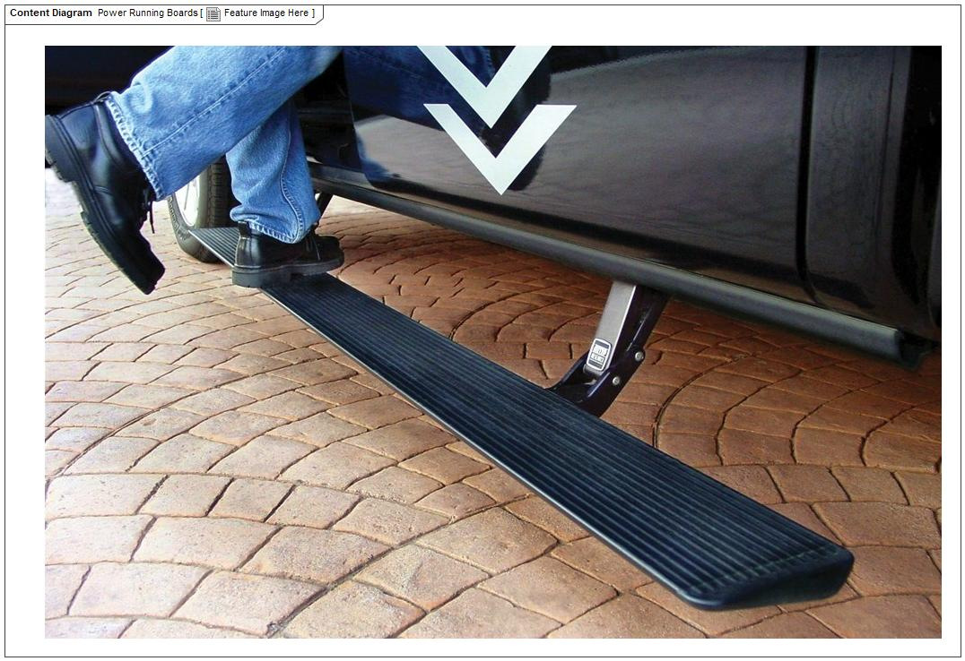

Figure 1: Feature Image Here

## Feature Variants

**#Hint:** List all known variants of the feature applying to current and upcoming programs. Reference each variant by a descriptive name. If no variant exists, state “No Feature Variants”. The “Variant Description” table column should give a short informative text, which describes the variant of the feature.

Requirements in chapter “Feature Requirements”, which do not apply for all variants, should clearly state, which variants they are applicable for.

| **Variant Name** | **Variant Description** | **Remarks** |
| --- | --- | --- |
| **Power Running Boards <AU/ADWCD>** | p702 |  |

Table 6: Feature Variants

### Regions & Markets

**#Hint:** Description of purpose and functionality of the feature. If there is no variant, give feature name in first column.

| **Market /**  **Region**  Variant Name | **North America** | **South America** | **Europe** | **Middle East/Africa** | **Asia / Pacific** | **China** |
| --- | --- | --- | --- | --- | --- | --- |
| **Power Running Boards <AU/ADWCD>** | Optional | Optional | No | Optional | Optional | Optional |

Table 7: Regions & Markets

## Input Requirements/Documents

**#Hint:** List relevant documents or requirements, which should be considered when considered when specifying the requirements in chapter “Feature Requirements” of this document. When finalizing the spec, the feature owner should check, if all inputs have been properly considered by derived/outgoing requirements.

**#Link:** Refer to “Forward Traceability” at [Stages – RE Traceabilty Record](https://bd101001.pd2.ford.com/stages/#/workspace/209/_vv/(process/artifact/_ZbIhsK4EkzaN49uPh7SLuQ))

| **Reference**  (Reference as listed in ch. “**Error! Reference source not found.**”) | **Section/Requirement** | **Description** | **Derived Requirement**  (optional – reference to requirement in ch. “**Error! Reference source not found.**”) |
| --- | --- | --- | --- |
| **Attribute Requirements** | | | |
|  | Example AR |  |  |
| **Ford Engineering Standards** | | | |
|  | <Example: some SDS (requirement)> |  |  |
| **Legal Regulations** | | | |
|  | Compliance with FMVSS101 | The Feature shall comply with FMVSS101. |  |
| **Industry Standards** | | | |
|  | ISO 26262 | The system should be developed according to Ford's implementation of Functional Safety. |  |
| **Other Sources** | | | |

Table 8: Input Requirements/Documents

## Lessons Learned

**#Hint:** Additional information and lessons learned from previous development or related features. A typical source for Lessons Learned is the FMA Quality History.

**#Functional Safety:** Insert (or reference) additional safety information and lessons learned from previous development of related items /features or legacy features, e.g., potential consequences of behavior shortfalls including known failure modes and hazards, already known safety requirements.

**#Link:** [FFSG01.10 Feature Document Guideline](https://azureford.sharepoint.com/sites/GlobalFunctionalSafety/Released%20Templates%20Guidelines%20and%20Examples/Guidelines/FFSG01.10_FeatureDocument_Guideline.pdf)

No lessons learned specified.

## Assumptions

**#Hint:** A list of known assumptions concerning the effects of the feature’s behavior on other features or elements (i.e., dependencies) as well as assumptions on the behavior expected by the feature (e.g. known limitations). During the course of the feature development most of those assumptions are typically either converted into actual requirements or discarded at some point – such that this chapter remains mostly empty.  
**#Functional Safety:** For assumptions, which are relevant for the Functional Safety process refer to chapter 6.2 “Functional Safety Assumptions”

Feature Assumptions

* PRB setting modes OFF and OUT will override all AUTO settings.
* The kick switch will override all AUTO settings and hold PRB in state.
* If the vehicle speed >= Max permissible speed, the PRB will go to stow.
* Kick Switch takes priority (Unless vehicle is locked and kick switch setting mode is unlock only).
* Door open takes the next priority
* If PRB timer is currently running and a new trigger occurs then restart timer (excepting Lock/Unlock).
* If PRB set to out and vehicle speed is >= Max permissible speed then PRB changes mode to auto and stows

|  |
| --- |
| **Purpose** |
|  |

# Feature Context

## Feature Context Diagram

**#Hint:** High level diagram of feature interactions with the environment, people or other feature or other external entities.

**#Functional Safety:** The Context Diagram is not required, if the Feature Document is only used as an Item Definition (not as a requirements specification). In that case the Item Boundary is defined in chapter “**Error! Reference source not found.**”.

**#Link:** [*Stages- RE Model the Context*](https://bd101001.pd2.ford.com/stages/#/workspace/209/_vv/(process/activity/_RwbBQG35kpCMg85u0m-tig))

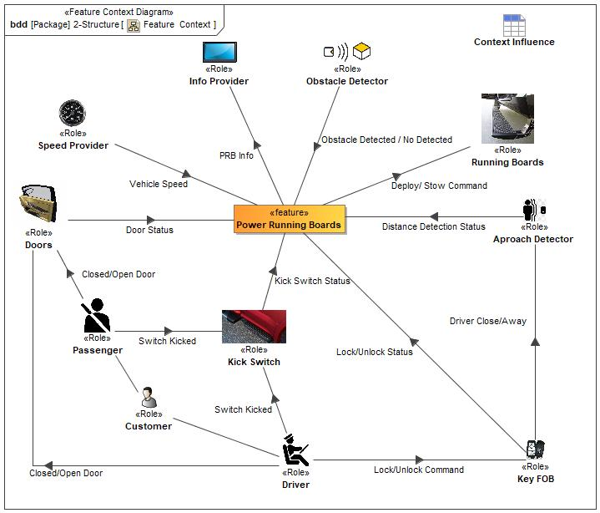

Figure 2: Feature Context

## List of Influences

| **ID** | **External Entity** | **Influence Description** |
| --- | --- | --- |
| Closed/Open Door | Driver To Doors | It shows the command of Closed and Open. |
| Passenger To Doors | It shows the command of Closed and Open. |
| Power Running Boards To Driver | It shows the command of Closed and Open. |
| Deploy/ Stow Command | Power Running Boards To Running Boards | It shows the command of deploy and stow |
| Distance Detection Status | Aproach Detector To Power Running Boards | It shows the status of Distance Detection. |
| Door Status | Doors To Power Running Boards | It shows the status of Door. |
| Driver Close/Away | Key FOB To Aproach Detector | It shows the Approach Detector range from driver |
| Power Running Boards To Key FOB | It shows the Approach Detector range from driver |
| Kick Switch Status | Kick Switch To Power Running Boards | It shows the status of Kick Switch. |
| Lock/Unlock Command | Driver To Key FOB | It shows the command of Lock/Unlock. |
| Lock/Unlock Status | Key FOB To Power Running Boards | It shows the status of Door Lock. |
| Obstacle Detected / No Detected | Obstacle Detector To Power Running Boards | It detects the obstacle |
| PRB Info | Power Running Boards To Info Provider | It shows the status of PRB feature. |
| Switch Kicked | Driver To Kick Switch | It shows the status of kick switch. |
| Passenger To Kick Switch | It shows the status of kick switch. |
| Vehicle Speed | Key FOB To Power Running Boards | It shows the Speed of the Vehicle |
| Speed Provider To Power Running Boards | It shows the Speed of the Vehicle |

Table 9: List of Influences

# Feature Modeling

**#Hint:** Use at least one of the modelling techniques listed in this chapter – and additionally a functional decomposition (refer to chapter **Error! Reference source not found.** “**Error! Reference source not found.**”) – to gather and analyze the feature requirements.

**#Link:** [*Stages- RE Analyze Feature Requirements*](https://bd101001.pd2.ford.com/stages/#/workspace/209/_vv/(process/activity/_E_h9QKJNeBGY2aIJCaFfcg))

## Operation Modes and States

**#Classification:** Optional (Mandatory for Functional Safety)

**#Hint:** Insert (or reference) a description of the feature’s operation modes and states by one or multiple state machine diagrams. The purpose of the state machine is to help analyze the requirements, i.e., if the behavior described in the requirements is consistent and complete. Therefore, the state machine should not provide details, which are not referenced in feature level requirements. It should typically show only those states and transitions, which describe the high level behavior facing or impacting the user.

**#Link:** [Stages - RE Model the States and Modes](https://bd101001.pd2.ford.com/stages/#/workspace/209/_vv/(process/activity/_iKH7oFMNkpOMg85u0m-tig))

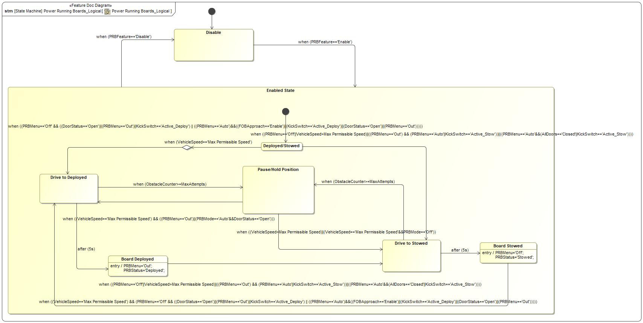

Figure 3: Power Running Boards_Logical

| **State** | **Description** | **Requirements Reference** (optional) |
| --- | --- | --- |
| Board Deployed | When the Motor angle rotates 90 then PRB will be Deployed. |  |
| Board Stowed | When the Motor angle rotates 90 then PRB will be Stowed. |  |
| Deployed/Stowed | Deployed/Stowed is the initial condition |  |
| Disable | PRB Feature is in Disable State |  |
| Drive to Deployed | PRB yet to be deployed. |  |
| Drive to Stowed | PRB yet to be stowed. |  |
| Enabled State | PRB Feature is in Enable State |  |
| Pause/Hold Position | It shows the current status of PRB. |  |

Table 10: Operation Modes and States on Power Running Boards_Logical

| **Transition ID** | **Source** | **Destination** | **Description** | **Requirements Reference**  (optional) |
| --- | --- | --- | --- | --- |
| T1 | Board Stowed | Drive to Deployed | ChangeEvent when ((VehicleSpeed=='Max Permissible Speed') && (PRBMenu=='Off' && ((DoorStatus=='Open')||(PRBMenu=='Out')||KickSwitch=='Active_Deploy') || ((PRBMenu=='Auto')&&((FOBApproach=='Enable')||(KickSwitch=='Active_Deploy')||(DoorStatus=='Open')||(PRBMenu=='Out'))))) |  |
| T2 | Pause/Hold Position | Drive to Deployed | ChangeEvent when ((VehicleSpeed=='Max Permissible Speed') && ((PRBMenu=='Out')||(PRBMode=='Auto'&&DoorStatus=='Open'))) |  |
| T3 | Deployed/Stowed | Deployed/Stowed | Name: Deployed/Stowed |  |
| T4 | Drive to Stowed | Pause/Hold Position | ChangeEvent when (ObstacleCounter>=MaxAttempts) |  |
| T5 | Pause/Hold Position | Drive to Stowed | ChangeEvent when ((VehicleSpeed>Max Permissible Speed)||(VehicleSpeed=='Max Permissible Speed'&&PRBMode=='Off')) |  |
| T6 | Deployed/Stowed | Drive to Stowed | ChangeEvent when ((PRBMenu=='Off'||VehicleSpeed>Max Permissible Speed)||((PRBMenu=='Out') && (PRBMenu=='Auto'||KickSwitch=='Active_Stow'))||((PRBMenu=='Auto'&&(AllDoors=='Closed'||KickSwitch=='Active_Stow')))) |  |
| T7 | Drive to Stowed | Board Stowed | TimeEvent after (5s) |  |
| T8 | Drive to Deployed | Pause/Hold Position | ChangeEvent when (ObstacleCounter>=MaxAttempts) |  |
| T9 | Deployed/Stowed | checks Vehicle Speed | ChangeEvent when (VehicleSpeed=='Max Permissible Speed') |  |
| T10 | Board Deployed | Drive to Stowed | ChangeEvent when ((PRBMenu=='Off'||VehicleSpeed>Max Permissible Speed)||((PRBMenu=='Out') && (PRBMenu=='Auto'||KickSwitch=='Active_Stow'))||((PRBMenu=='Auto'&&(AllDoors=='Closed'||KickSwitch=='Active_Stow')))) |  |
| T11 | Disable | Enabled State | ChangeEvent when (PRBFeature=='Enable') |  |
| T12 | Drive to Deployed | Board Deployed | TimeEvent after (5s) |  |
| T13 | checks Vehicle Speed | Drive to Deployed | ChangeEvent when ((PRBMenu=='Off' && ((DoorStatus=='Open')||(PRBMenu=='Out')||KickSwitch=='Active_Deploy') || ((PRBMenu=='Auto')&&((FOBApproach=='Enable')||(KickSwitch=='Active_Deploy')||(DoorStatus=='Open')||(PRBMenu=='Out'))))) |  |
| T14 | Enabled State | Disable | ChangeEvent when (PRBFeature=='Disable') |  |
| T15 |  |  |  |  |

Table 11: Transitions between Operation Modes and States on Power Running Boards_Logical

## Use Cases

**#Classification:** Optional (Mandatory for Functional Safety)

**#Hint:** Describe (or reference) the ways the user interacts with the system

**#Link:** [Stages - RE Model a Use Case](https://bd101001.pd2.ford.com/stages/#/workspace/209/_vv/(process/activity/_A8UUYPnykpCMg85u0m-tig))

### Use Case Diagram

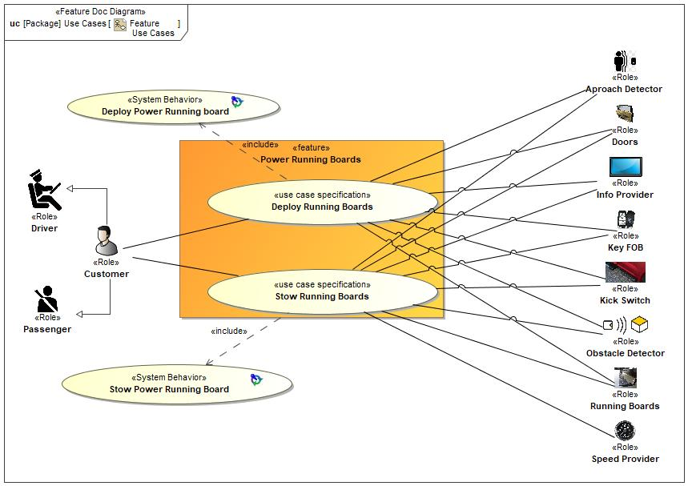

Figure 4: Feature

Use Cases

### Actors

| **Actor** | **Description** |
| --- | --- |
| Aproach Detector | Its nothing but FOB |
| Customer | Customer |
| Doors | It provides the door status |
| Driver | Driver operates this Feature |
| Info Provider | It provides the feature information |
| Key FOB | It provides the status of Key FOB |
| Kick Switch | It provides the Kick switch status |
| Obstacle Detector | It detects the obstacle |
| Passenger | Passenger |
| Running Boards | It provides the running board status |
| Speed Provider | It provides the vehicle speed |

Table 12: List of Actors

### Use Case Descriptions

**#Classification:** Optional (Mandatory for Functional Safety)

**#Macro:** [Add Ins -> Add Requirement macro](http://wiki.ford.com/display/RequirementsEngineering/How+to+use+the+Specification+Templates#HowtousetheSpecificationTemplates-AddNewRequirement) (select “Use Case” as type)

Stow Running Boards

|  |  |  |
| --- | --- | --- |
| **Actors** | Primary | Customer |
| Secondary | Aproach Detector |
| Secondary | Doors |
| Secondary | Info Provider |
| Secondary | Key FOB |
| Secondary | Kick Switch |
| Secondary | Obstacle Detector |
| Secondary | Running Boards |
| Secondary | Speed Provider |
| **Subject** |  | Power Running Boards |
| **Description** |  | The power running board is intended to assist occupants to step into and out of the vehicle. |
| **Preconditions** | PreC1 | The PRBs are in the deployed state |
| PreC2 | The vehicle has the doors closed |
| PreC3 | The vehicle has the doors locked |
| **Main Flow Description** |  | This is the main logic scenario |
| **Main Flow** | M1 | The customer gets into the vehicle |
| M2 | In AUTO mode the customer closes the doors |
| M3 | The PRBs drive to the stowed state |
| **Alternative Flow Description** |  | There are different triggers available to stow the PRBs |
| **Alternative Flow Steps** | A1 | M1 In AUTO mode the customer exits the approach detection zone |
| A2 | M2 In AUTO mode the customer locks the vehicle with the Key FOB |
| A3 | M2 Customer select in the HMI interface the OFF mode |
| A4 | M2 The customer drives the vehicle at a speed higher than the maximum permissible |
| A5 | M2 Customer commands the power running boards through kick switch |
| **Exceptional Flow Description** |  | Continuos after M3 |
| **Exceptional Flow Steps** | E1 | If the vehicle speed is higher than the maximum permissible, the setting modes in the HMI will not be available |
| E2 | If the vehicle speed is higher than the maximum permissible, the setting mode changes to AUTO |
| E3 | If there is an obstacle detected the running board will reverse direction to the deployed state |
| E4 | If the obstacle is not removed after 3 attemps the power running board will pause or hold its position |
| E5 | If the approach detection is disabled by the customer it will not stow the power running board |
| **Postconditions** | PostC1 | If the PRB is in “Board Stowed” State, the Motor shall not be driven |
| PostC2 | In the “Board Stowed” State, the PRB shall remain stowed both power running boards are tucked close to the body of the vehicle and the step surface is NOT accessible |

Deploy Running Boards

|  |  |  |
| --- | --- | --- |
| **Actors** | Primary | Customer |
| Secondary | Aproach Detector |
| Secondary | Doors |
| Secondary | Info Provider |
| Secondary | Key FOB |
| Secondary | Kick Switch |
| Secondary | Obstacle Detector |
| Secondary | Running Boards |
| **Subject** |  | Power Running Boards |
| **Description** |  | The power running board is intended to assist occupants to step into and out of the vehicle. |
| **Preconditions** | PreC1 | The PRBs are in the stowed state |
| PreC2 | The customer needs to be at least 1.5 m close to the vehicle |
| PreC3 | The ignition status is off, vehicle speed = 0 kph |
| PreC4 | The vehicle has the doors opened |
| PreC5 | The vehicle has the doors unlocked |
| **Main Flow Description** |  | This is the main logic scenario |
| **Main Flow** | M1 | Customer is outside the vehicle and approachs to it with the Key FOB |
| M2 | In AUTO mode the customer is detected by the Approach Detector |
| M3 | The PRBs drive to the deployed state |
| **Alternative Flow Description** |  | There are different triggers available to deploy the PRBs |
| **Alternative Flow Steps** | A1 | M2 In AUTO mode the customer gets out of the vehicle oppening the doors |
| A2 | M2 In AUTO mode the customer unlocks the vehicle with the Key FOB |
| A3 | M2 Customer select in the HMI interface the OUT mode |
| A4 | M2 Customer commands the power running boards through kick switch |
| **Exceptional Flow Description** |  | Continuos after M3 |
| **Exceptional Flow Steps** | E1 | If the vehicle speed is higher than the maximum permissible, the setting modes in the HMI will not be available |
| E2 | The timer to stow does not restart if the doors are opened, the vehicle is unlocked or the approch detection occurs |
| E3 | If there is an obstacle detected the running board will reverse direction to the stowed state |
| E4 | If the obstacle is not removed after 3 attemps the power running board will pause or hold its position |
| E5 | If the approach detection is disabled by the customer it will not deploy the power running board |
| **Postconditions** | PostC1 | If the PRB is in “Board Deployed” State, the motor shall not be driven |
| PostC2 | In the “Board Deployed” State, the PRB shall remain deployed both power running boards are extended away from the body of the vehicle and the step surface is accessible |

## Driving and Operation Scenarios

**#Classification:** Optional (Mandatory for Functional Safety)

**#Hint:** “Driving Scenario” is a story-board like technique, which focusses on the feature interacting with its environment.

**#Functional Safety**: Describe (or reference) driving and operating scenarios that impact the functionality of the item/feature, including potential operational and environmental constraints. The objective of this section is to describe the environment of the feature in order to understand its impact on the feature. Concept FMEA and P-diagram may be an input for this section.

**#Macro:** [Add Ins -> Add Requirement macro](http://wiki.ford.com/display/RequirementsEngineering/How+to+use+the+Specification+Templates#HowtousetheSpecificationTemplates-AddNewRequirement) (select “Scenario” as type)

**#Link:** [Stages - RE Model a Driving Situation](https://bd101001.pd2.ford.com/stages/#/workspace/209/_vv/(process/activity/_KC_OMN4hkpGMg85u0m-tig))

Deploy running boards

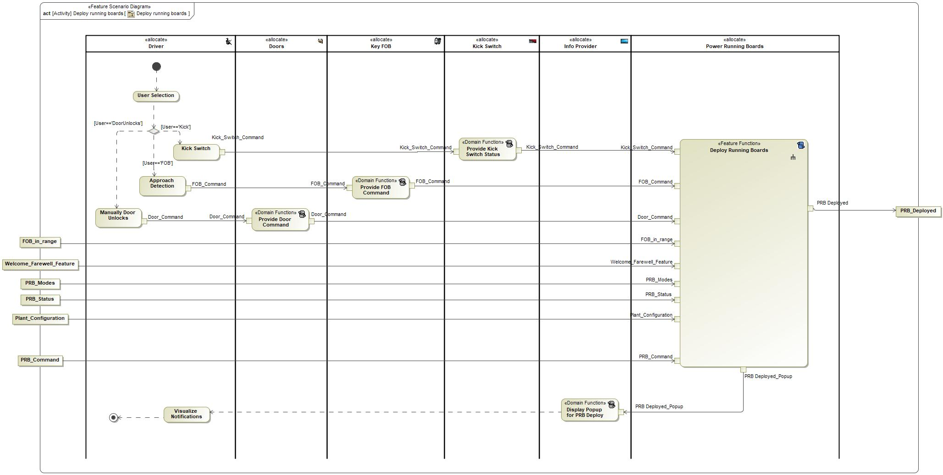

Figure 5: Deploy running boards

Functional Boundary Behavior

Description of the diagram and content about Functional Architecture in Documentation field of Functional Boundary Diagram.

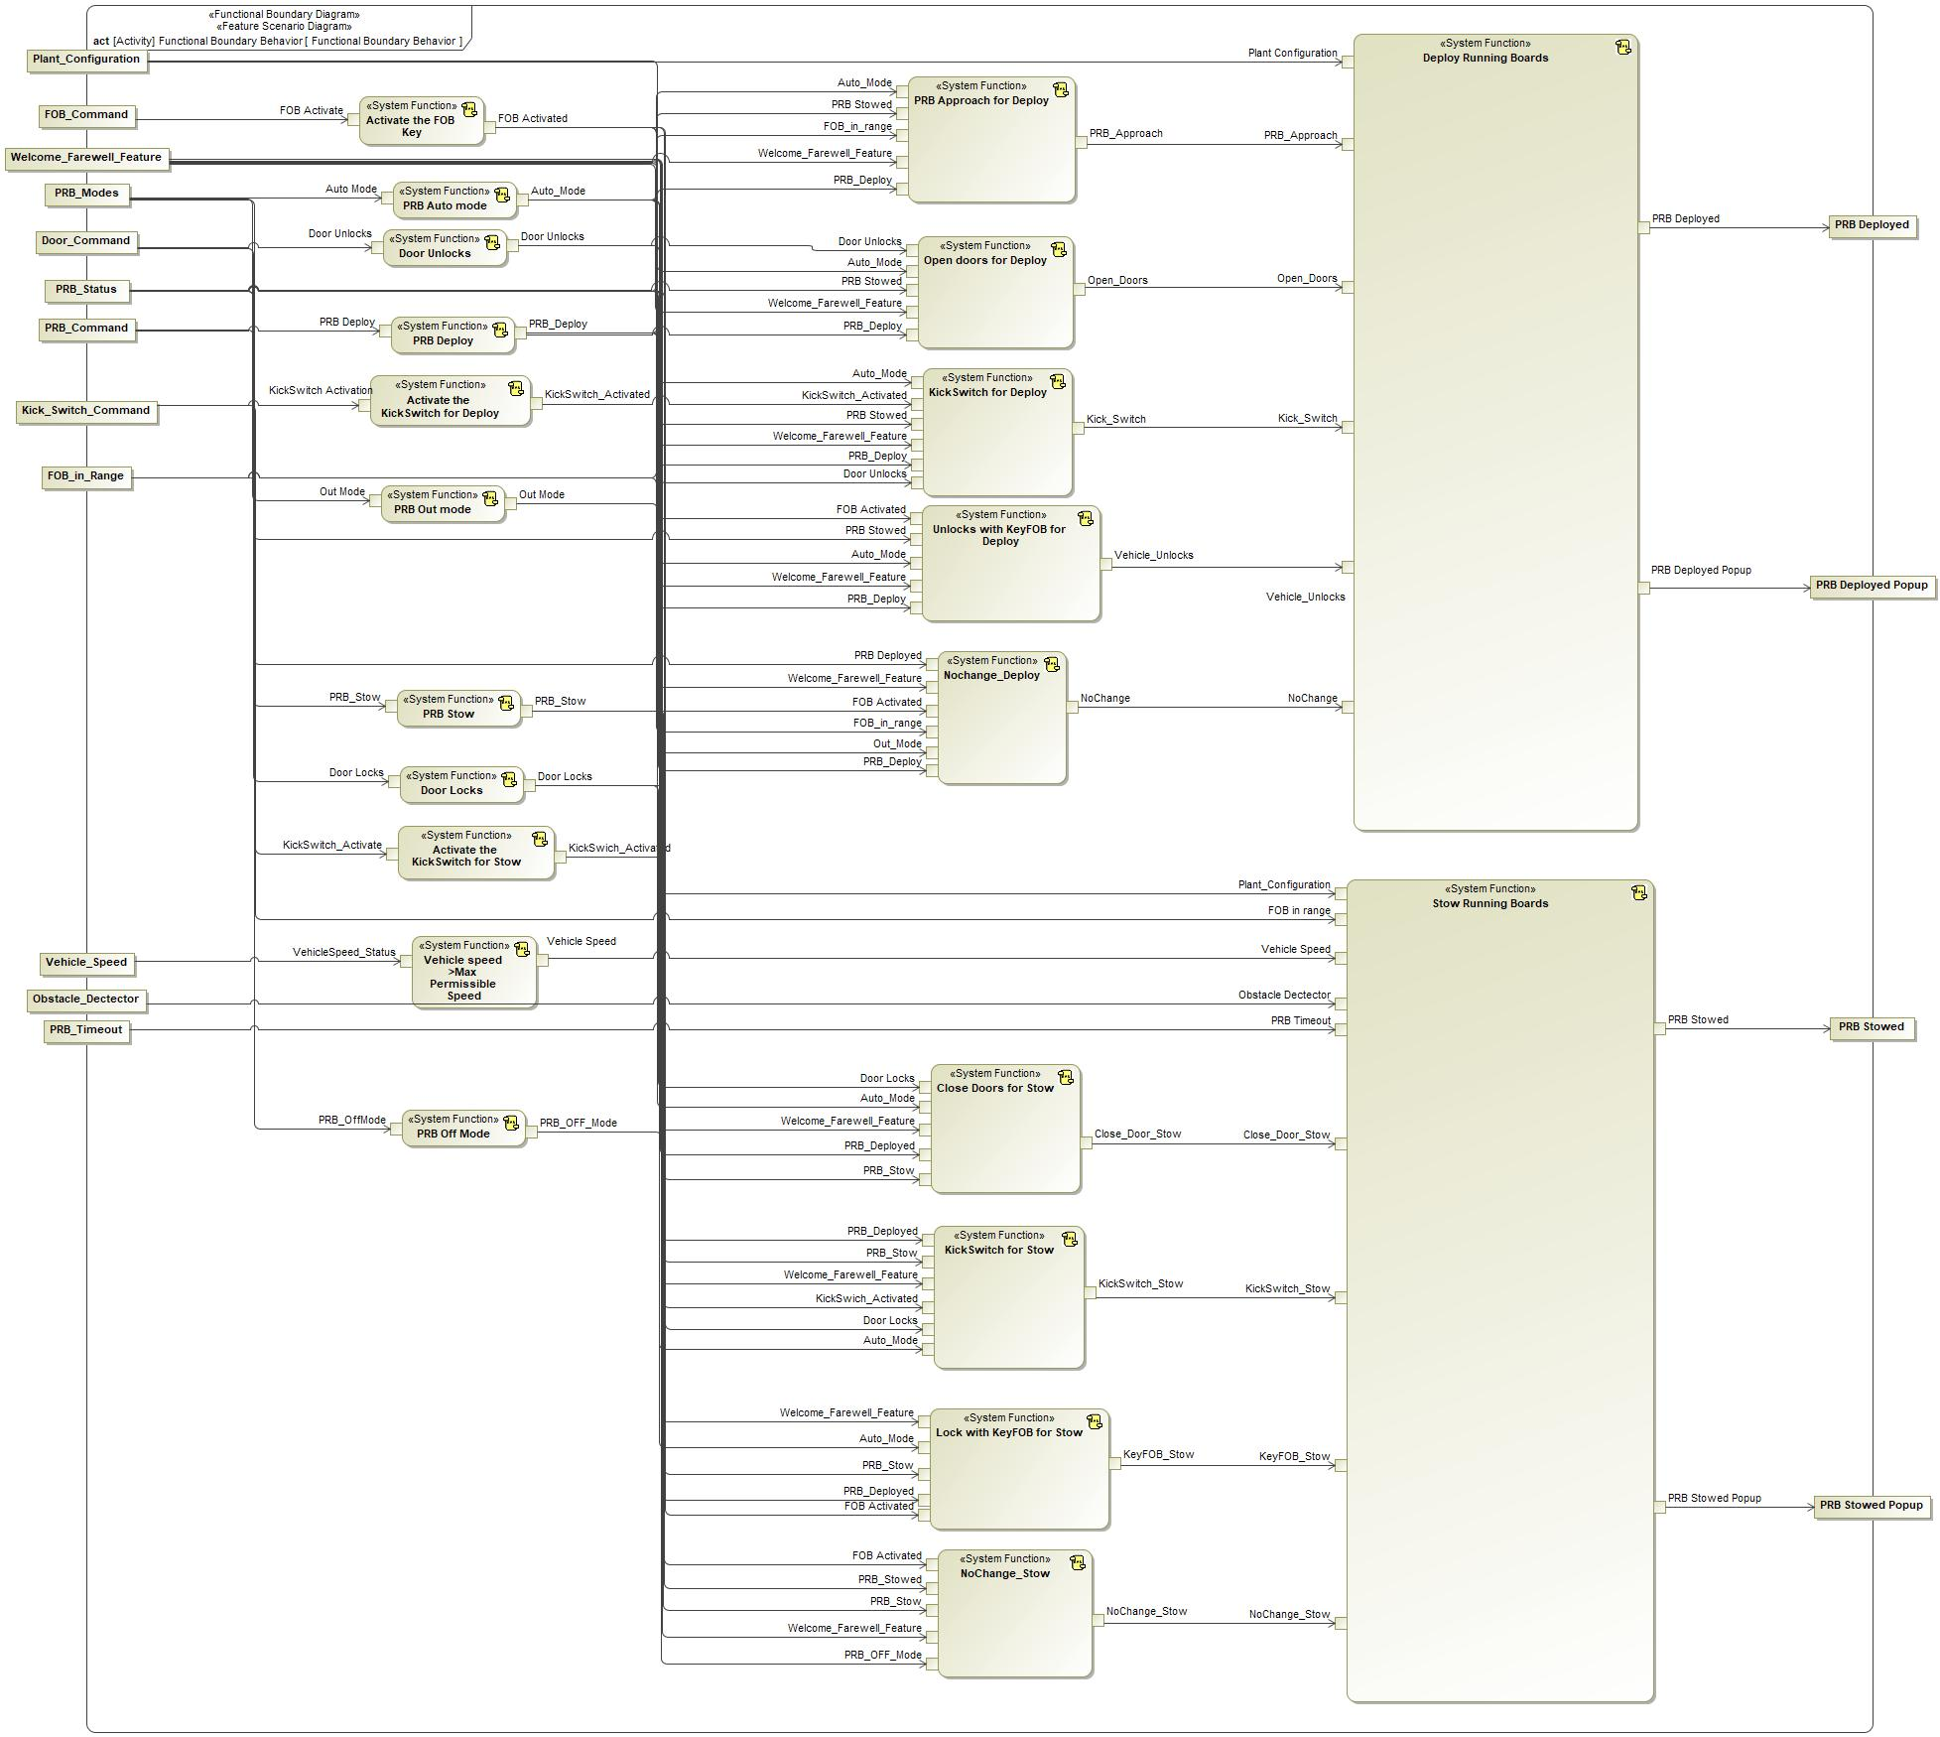

Figure 6: Functional Boundary Behavior

SC_FNC_00001

Description of the scenario in the Documentation field on the Feature Scenario Diagram.

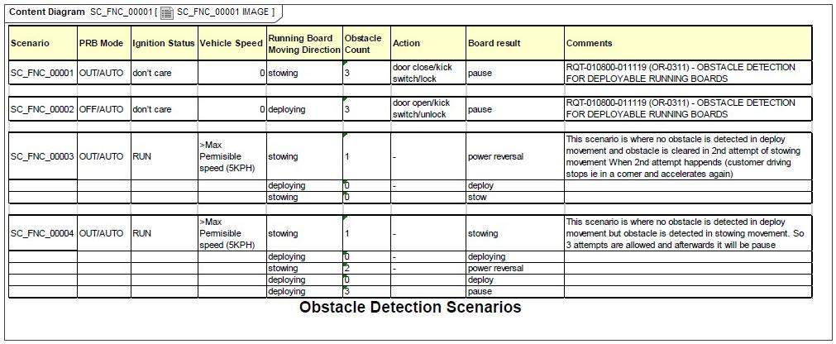

Figure 7: SC_FNC_00001

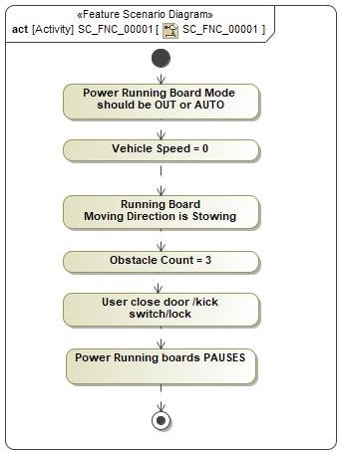

Figure 8: SC_FNC_00001

SC_FNC_00002

Description of the scenario in the Documentation field on the Feature Scenario Diagram.

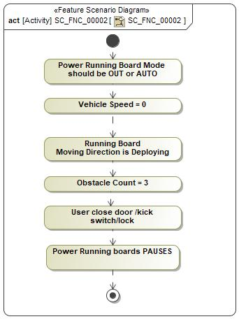

Figure 9: SC_FNC_00002

SC_FNC_00003

Description of the scenario in the Documentation field on the Feature Scenario Diagram.

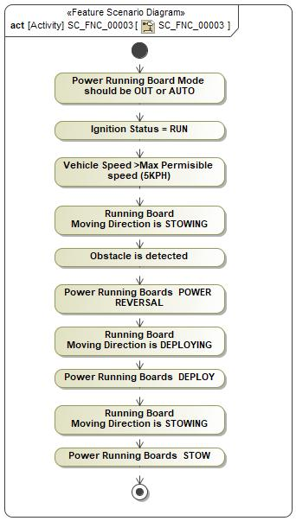

Figure 10: SC_FNC_00003

SC_FNC_00004

Description of the scenario in the Documentation field on the Feature Scenario Diagram.

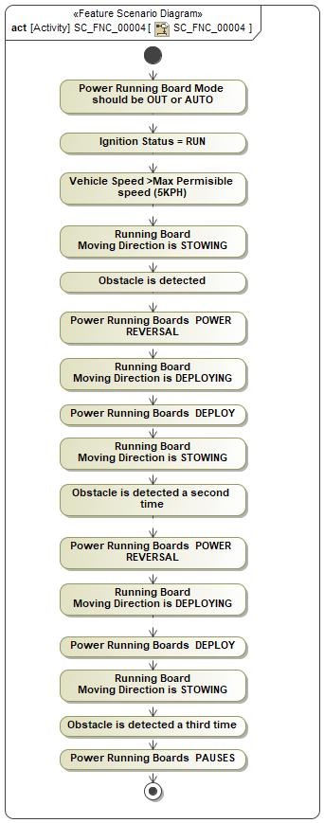

Figure 11: SC_FNC_00004

Stow Running Boards

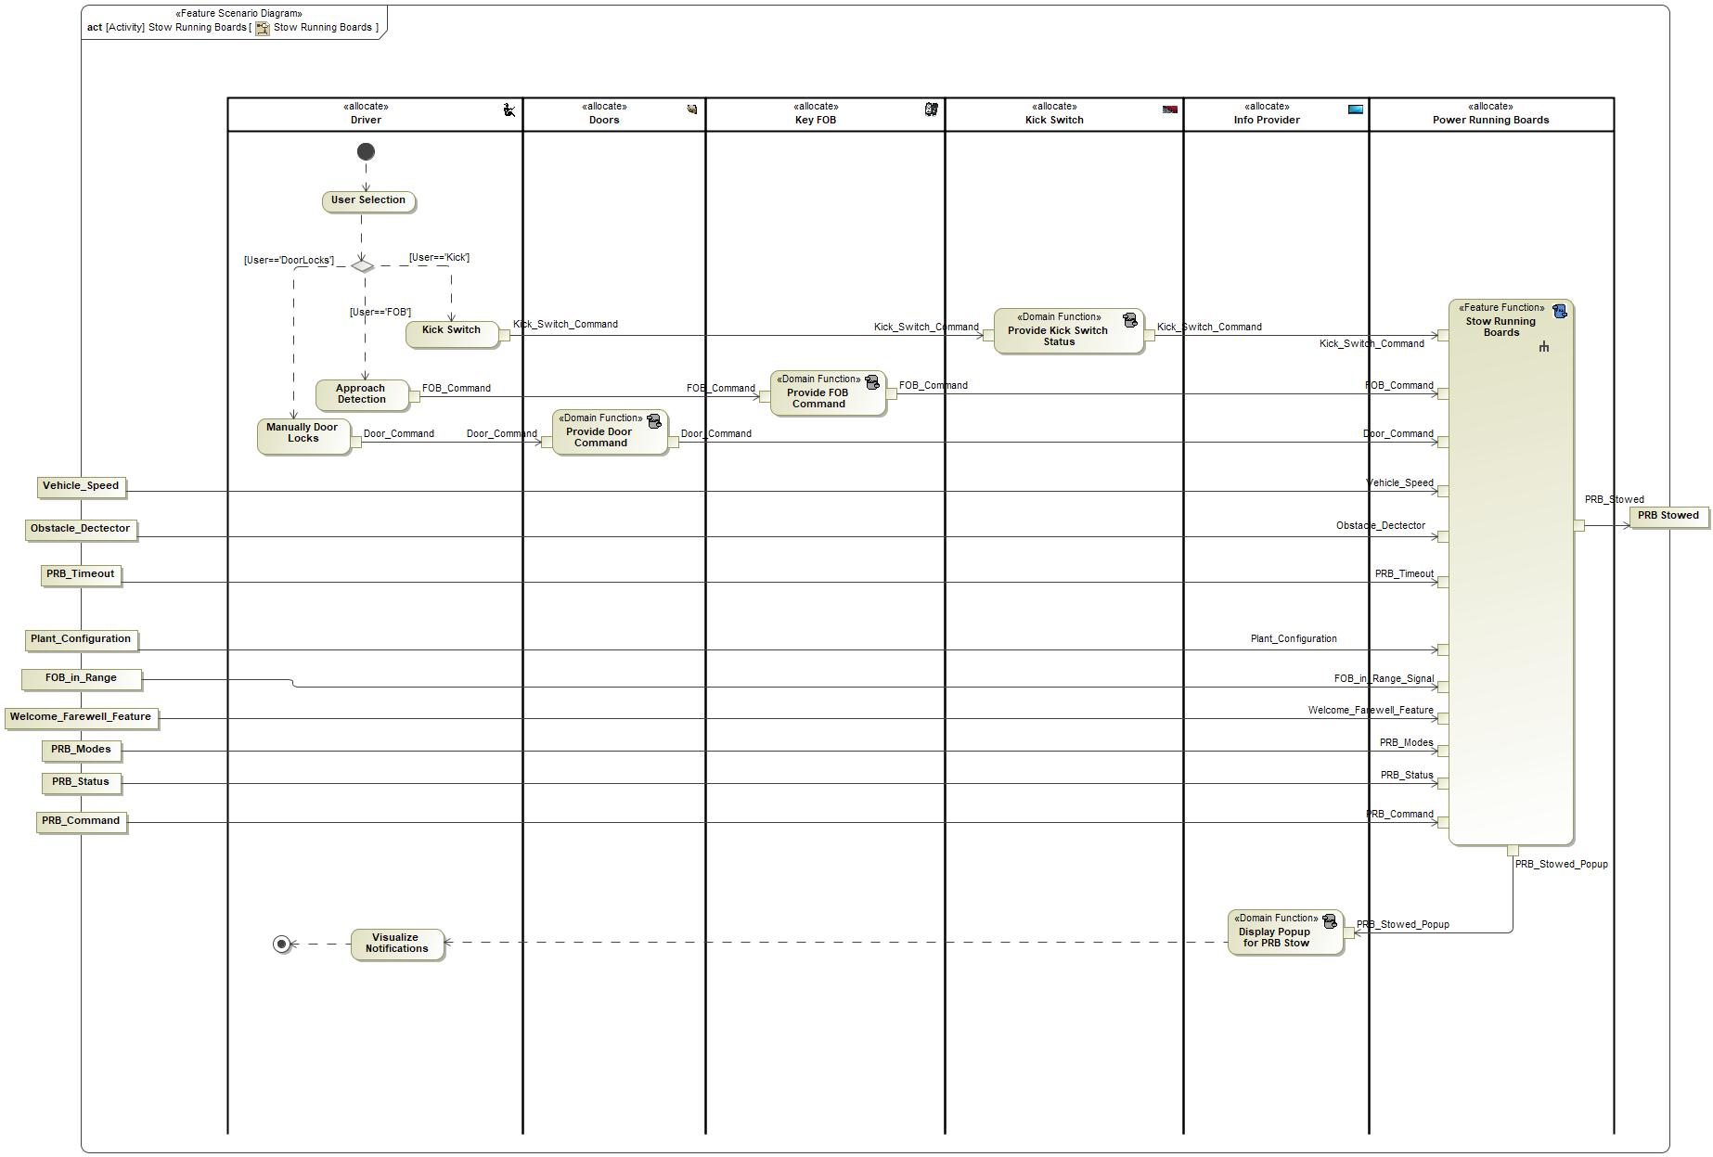

Figure 12: Stow Running Boards

## Decision Tables

**#Classification:** Optional (Remove, if not used)

**#Hint:** Use decision table, if behavior is not state based (in that case prefer state chart from ch. 4.1) and based purely on current inputs.

**#Link:** [RE Wiki – Decision Tables](http://wiki.ford.com/display/RequirementsEngineering/Decision+Table).

# Feature Requirements

**#Hint**: Include functional requirements specifying quality, performance and availability of the functionality.   
The subsections contained in this chapter help not to forget aspects, which are typically relevant on Concept Level. It is not possible and not required to always strictly classify a requirement according to the subsections.

Alternatively, this chapter could be structured according to the functions derived in chapter “**Error! Reference source not found.**”, i.e., each function comes with its own heading and related requirements are listed beneath.

**#Functional Safety:** In general, safety requirements are not listed here. However, it is possible that later in the development process, a non-safety requirement becomes a safety requirement. In such a case it may remain on this list.

**#Macro:** [Add Ins -> Add Requirement macro](https://wiki.ford.com/pages/viewpage.action?pageId=174654231) (select “Requirement” as type)

**#Link:** [Stages - RE Specify Feature Requirements](https://bd101001.pd2.ford.com/stages/#/workspace/209/_vv/(process/activity/_Q_2kYJ6ceBKY2aIJCaFfcg)).

## Functional Requirements

**#Hint:** Functional requirements specify the functionality of the feature, i.e., what the feature shall do. Functional requirements should not only specify the normal flow/behavior, but also exceptional cases/error handling.

Test Functional Requirement

|  |  |  |  |  |  |  |  |
| --- | --- | --- | --- | --- | --- | --- | --- |
| Requirement ID: | | | | | | | |
| **Rationale** |  | | | | | | |
| **Acceptance Criteria** |  | | | | | | |
| **Notes** |  | | | | | | |
| **Source** |  | | | | | **Owner** |  |
| **Source Req.** |  | | | | | **V&V Method** |  |
| **Type** |  | | | **Priority** |  | **Status** |  |
| [Req. Template](http://wiki.ford.com/display/RequirementsEngineering/Requirements+Attributes) Version | | 6.0 | End of Requirement | | | | |

R_F_PRB_00001 PRB Operation modes

The Power running Board Feature shall be set in one of the three setting modes “AUTO”, “OUT” or “OFF”.

|  |  |  |  |  |  |  |  |
| --- | --- | --- | --- | --- | --- | --- | --- |
| Requirement ID: R_F_PRB_00001 | | | | | | | |
| **Rationale** |  | | | | | | |
| **Acceptance Criteria** |  | | | | | | |
| **Notes** |  | | | | | | |
| **Source** |  | | | | | **Owner** |  |
| **Source Req.** |  | | | | | **V&V Method** |  |
| **Type** |  | | | **Priority** |  | **Status** | In-Progress |
| [Req. Template](http://wiki.ford.com/display/RequirementsEngineering/Requirements+Attributes) Version | | 6.0 | End of Requirement | | | | |

R_F_PRB_00002 PRB Default operation mode

The PRB setting mode default for Production and Factory modes shall be “AUTO” mode.

|  |  |  |  |  |  |  |  |
| --- | --- | --- | --- | --- | --- | --- | --- |
| Requirement ID: R_F_PRB_00002 | | | | | | | |
| **Rationale** |  | | | | | | |
| **Acceptance Criteria** |  | | | | | | |
| **Notes** |  | | | | | | |
| **Source** |  | | | | | **Owner** |  |
| **Source Req.** |  | | | | | **V&V Method** |  |
| **Type** |  | | | **Priority** |  | **Status** | In-Progress |
| [Req. Template](http://wiki.ford.com/display/RequirementsEngineering/Requirements+Attributes) Version | | 6.0 | End of Requirement | | | | |

R_F_PRB_00003 Both PRB sides stow at the same time

When an event for stowing the running board occurs, both PRB sides shall be stowed at the same time

|  |  |  |  |  |  |  |  |
| --- | --- | --- | --- | --- | --- | --- | --- |
| Requirement ID: R_F_PRB_00003 | | | | | | | |
| **Rationale** |  | | | | | | |
| **Acceptance Criteria** |  | | | | | | |
| **Notes** |  | | | | | | |
| **Source** |  | | | | | **Owner** |  |
| **Source Req.** |  | | | | | **V&V Method** |  |
| **Type** |  | | | **Priority** |  | **Status** | In-Progress |
| [Req. Template](http://wiki.ford.com/display/RequirementsEngineering/Requirements+Attributes) Version | | 6.0 | End of Requirement | | | | |

R_F_PRB_00004 PRB Transport Default operation mode

In Transport Mode, the PRBs shall function only with engine running (regardless of ignition status).

|  |  |  |  |  |  |  |  |
| --- | --- | --- | --- | --- | --- | --- | --- |
| Requirement ID: R_F_PRB_00004 | | | | | | | |
| **Rationale** |  | | | | | | |
| **Acceptance Criteria** |  | | | | | | |
| **Notes** |  | | | | | | |
| **Source** |  | | | | | **Owner** |  |
| **Source Req.** |  | | | | | **V&V Method** |  |
| **Type** |  | | | **Priority** |  | **Status** | In-Progress |
| [Req. Template](http://wiki.ford.com/display/RequirementsEngineering/Requirements+Attributes) Version | | 6.0 | End of Requirement | | | | |

R_F_PRB_00005 PRB Commands only in the Auto mode

In an Approach detection, door opened and lock/unlock commands the PRB shall work in AUTO mode only.

|  |  |  |  |  |  |  |  |
| --- | --- | --- | --- | --- | --- | --- | --- |
| Requirement ID: R_F_PRB_00005 | | | | | | | |
| **Rationale** |  | | | | | | |
| **Acceptance Criteria** |  | | | | | | |
| **Notes** |  | | | | | | |
| **Source** |  | | | | | **Owner** |  |
| **Source Req.** |  | | | | | **V&V Method** |  |
| **Type** |  | | | **Priority** |  | **Status** | In-Progress |
| [Req. Template](http://wiki.ford.com/display/RequirementsEngineering/Requirements+Attributes) Version | | 6.0 | End of Requirement | | | | |

R_F_PRB_00006 PRB Stow when Vehicle speed limit > Max Permissible Speed.

If the Vehicle speed > Max permissible speed, it shall take priority and go to “Drive to stow” state.

|  |  |  |  |  |  |  |  |
| --- | --- | --- | --- | --- | --- | --- | --- |
| Requirement ID: R_F_PRB_00006 | | | | | | | |
| **Rationale** |  | | | | | | |
| **Acceptance Criteria** |  | | | | | | |
| **Notes** |  | | | | | | |
| **Source** |  | | | | | **Owner** |  |
| **Source Req.** |  | | | | | **V&V Method** |  |
| **Type** |  | | | **Priority** |  | **Status** | In-Progress |
| [Req. Template](http://wiki.ford.com/display/RequirementsEngineering/Requirements+Attributes) Version | | 6.0 | End of Requirement | | | | |

R_F_PRB_00007 If Vehicle speed limit > Max Permissible Speed setting mode changes to AUTO

If Vehicle speed > Max permissible speed, the setting mode shall be changed to AUTO.

|  |  |  |  |  |  |  |  |
| --- | --- | --- | --- | --- | --- | --- | --- |
| Requirement ID: R_F_PRB_00007 | | | | | | | |
| **Rationale** |  | | | | | | |
| **Acceptance Criteria** |  | | | | | | |
| **Notes** |  | | | | | | |
| **Source** |  | | | | | **Owner** |  |
| **Source Req.** |  | | | | | **V&V Method** |  |
| **Type** |  | | | **Priority** |  | **Status** | In-Progress |
| [Req. Template](http://wiki.ford.com/display/RequirementsEngineering/Requirements+Attributes) Version | | 6.0 | End of Requirement | | | | |

R_F_PRB_00008 PRB setting mode priority

If the driver selects OFF or OUT operation modes, all “AUTO” setting shall be override.

|  |  |  |  |  |  |  |  |
| --- | --- | --- | --- | --- | --- | --- | --- |
| Requirement ID: R_F_PRB_00008 | | | | | | | |
| **Rationale** |  | | | | | | |
| **Acceptance Criteria** |  | | | | | | |
| **Notes** |  | | | | | | |
| **Source** |  | | | | | **Owner** |  |
| **Source Req.** |  | | | | | **V&V Method** |  |
| **Type** |  | | | **Priority** |  | **Status** | In-Progress |
| [Req. Template](http://wiki.ford.com/display/RequirementsEngineering/Requirements+Attributes) Version | | 6.0 | End of Requirement | | | | |

R_F_PRB_00009 Time to Stow” Variable

The “Time to Stow” Timer is used to delay stow operation in AUTO mode after the PRBs are deployed. This variable shall be configurable at EOL.

|  |  |  |  |  |  |  |  |
| --- | --- | --- | --- | --- | --- | --- | --- |
| Requirement ID: R_F_PRB_00009 | | | | | | | |
| **Rationale** |  | | | | | | |
| **Acceptance Criteria** |  | | | | | | |
| **Notes** |  | | | | | | |
| **Source** |  | | | | | **Owner** |  |
| **Source Req.** |  | | | | | **V&V Method** |  |
| **Type** |  | | | **Priority** |  | **Status** | In-Progress |
| [Req. Template](http://wiki.ford.com/display/RequirementsEngineering/Requirements+Attributes) Version | | 6.0 | End of Requirement | | | | |

R_F_PRB_00010 Max permissible Speed” Variable

The “Max permissible speed” is defined as the Vehicle Speed limit with the PRB deployed, this variable shall be configurable at EOL.

|  |  |  |  |  |  |  |  |
| --- | --- | --- | --- | --- | --- | --- | --- |
| Requirement ID: R_F_PRB_00010 | | | | | | | |
| **Rationale** |  | | | | | | |
| **Acceptance Criteria** |  | | | | | | |
| **Notes** |  | | | | | | |
| **Source** |  | | | | | **Owner** |  |
| **Source Req.** |  | | | | | **V&V Method** |  |
| **Type** |  | | | **Priority** |  | **Status** | In-Progress |
| [Req. Template](http://wiki.ford.com/display/RequirementsEngineering/Requirements+Attributes) Version | | 6.0 | End of Requirement | | | | |

R_F_PRB_00011 Max Motor Current” Variable

The “Max Motor Current” is the maximum current cutoff defined before exerting an unsafe squeeze force; this variable shall be configurable at EOL.

|  |  |  |  |  |  |  |  |
| --- | --- | --- | --- | --- | --- | --- | --- |
| Requirement ID: R_F_PRB_00011 | | | | | | | |
| **Rationale** |  | | | | | | |
| **Acceptance Criteria** |  | | | | | | |
| **Notes** |  | | | | | | |
| **Source** |  | | | | | **Owner** |  |
| **Source Req.** |  | | | | | **V&V Method** |  |
| **Type** |  | | | **Priority** |  | **Status** | In-Progress |
| [Req. Template](http://wiki.ford.com/display/RequirementsEngineering/Requirements+Attributes) Version | | 6.0 | End of Requirement | | | | |

R_F_PRB_00012 “Pooling Disable Time”

The “Pooling Disable Time” shall be 2.5 minutes for vehicle with regular PK battery and 10 minutes for vehicles with AVG.

|  |  |  |  |  |  |  |  |
| --- | --- | --- | --- | --- | --- | --- | --- |
| Requirement ID: R_F_PRB_00012 | | | | | | | |
| **Rationale** |  | | | | | | |
| **Acceptance Criteria** |  | | | | | | |
| **Notes** |  | | | | | | |
| **Source** |  | | | | | **Owner** |  |
| **Source Req.** |  | | | | | **V&V Method** |  |
| **Type** |  | | | **Priority** |  | **Status** | In-Progress |
| [Req. Template](http://wiki.ford.com/display/RequirementsEngineering/Requirements+Attributes) Version | | 6.0 | End of Requirement | | | | |

R_F_PRB_00013 PRB Cycle time at component level

At a component level, the Running Board Power Mechanism (RBPM) shall be capable of fully deploying the running board in a maximum of 1.5 seconds

|  |  |  |  |  |  |  |  |
| --- | --- | --- | --- | --- | --- | --- | --- |
| Requirement ID: R_F_PRB_00013 | | | | | | | |
| **Rationale** |  | | | | | | |
| **Acceptance Criteria** |  | | | | | | |
| **Notes** |  | | | | | | |
| **Source** |  | | | | | **Owner** |  |
| **Source Req.** |  | | | | | **V&V Method** |  |
| **Type** |  | | | **Priority** |  | **Status** | In-Progress |
| [Req. Template](http://wiki.ford.com/display/RequirementsEngineering/Requirements+Attributes) Version | | 6.0 | End of Requirement | | | | |

R_F_PRB_00014 PRB Cycle time at Vehicle level_1

At a vehicle level, the system shall be capable of deploying the PRB in less than 2.0 seconds from the time an appropriate door is unlatched.

|  |  |  |  |  |  |  |  |
| --- | --- | --- | --- | --- | --- | --- | --- |
| Requirement ID: R_F_PRB_00014 | | | | | | | |
| **Rationale** |  | | | | | | |
| **Acceptance Criteria** |  | | | | | | |
| **Notes** |  | | | | | | |
| **Source** |  | | | | | **Owner** |  |
| **Source Req.** |  | | | | | **V&V Method** |  |
| **Type** |  | | | **Priority** |  | **Status** | In-Progress |
| [Req. Template](http://wiki.ford.com/display/RequirementsEngineering/Requirements+Attributes) Version | | 6.0 | End of Requirement | | | | |

R_F_PRB_00015 PRB Cycle time at Vehicle level_2

The PRB shall reduce PWM when ending 10% of travel to avoid clunking.

|  |  |  |  |  |  |  |  |
| --- | --- | --- | --- | --- | --- | --- | --- |
| Requirement ID: R_F_PRB_00015 | | | | | | | |
| **Rationale** |  | | | | | | |
| **Acceptance Criteria** |  | | | | | | |
| **Notes** |  | | | | | | |
| **Source** |  | | | | | **Owner** |  |
| **Source Req.** |  | | | | | **V&V Method** |  |
| **Type** |  | | | **Priority** |  | **Status** | In-Progress |
| [Req. Template](http://wiki.ford.com/display/RequirementsEngineering/Requirements+Attributes) Version | | 6.0 | End of Requirement | | | | |

R_F_PRB_00016 Special Event one when the time to stow does not restart

If the PRB status is deployed and a door is open or an unlock command or an AD event occur, the counter for time to stow shall not restart

|  |  |  |  |  |  |  |  |
| --- | --- | --- | --- | --- | --- | --- | --- |
| Requirement ID: R_F_PRB_00016 | | | | | | | |
| **Rationale** |  | | | | | | |
| **Acceptance Criteria** |  | | | | | | |
| **Notes** |  | | | | | | |
| **Source** |  | | | | | **Owner** |  |
| **Source Req.** |  | | | | | **V&V Method** |  |
| **Type** |  | | | **Priority** |  | **Status** | In-Progress |
| [Req. Template](http://wiki.ford.com/display/RequirementsEngineering/Requirements+Attributes) Version | | 6.0 | End of Requirement | | | | |

R_F_PRB_00017 PRB Status when “Board Stowed” State

If the PRB is in “Board Stowed” State, the PRB shall Remain Stowed close to the body of the vehicle and the step surface is NOT accessible

|  |  |  |  |  |  |  |  |
| --- | --- | --- | --- | --- | --- | --- | --- |
| Requirement ID: R_F_PRB_00017 | | | | | | | |
| **Rationale** |  | | | | | | |
| **Acceptance Criteria** |  | | | | | | |
| **Notes** |  | | | | | | |
| **Source** |  | | | | | **Owner** |  |
| **Source Req.** |  | | | | | **V&V Method** |  |
| **Type** |  | | | **Priority** |  | **Status** | In-Progress |
| [Req. Template](http://wiki.ford.com/display/RequirementsEngineering/Requirements+Attributes) Version | | 6.0 | End of Requirement | | | | |

R_F_PRB_00018 Motor when “Board Stowed” State

If the PRB is in “Board Stowed” State, the Motor shall not be driven.

|  |  |  |  |  |  |  |  |
| --- | --- | --- | --- | --- | --- | --- | --- |
| Requirement ID: R_F_PRB_00018 | | | | | | | |
| **Rationale** |  | | | | | | |
| **Acceptance Criteria** |  | | | | | | |
| **Notes** |  | | | | | | |
| **Source** |  | | | | | **Owner** |  |
| **Source Req.** |  | | | | | **V&V Method** |  |
| **Type** |  | | | **Priority** |  | **Status** | In-Progress |
| [Req. Template](http://wiki.ford.com/display/RequirementsEngineering/Requirements+Attributes) Version | | 6.0 | End of Requirement | | | | |

R_F_PRB_00019 Monitor inputs when “Board Stowed” State

If the PRB is in “Board Stowed” State, the next inputs shall be Monitored: PK, doors status, PRB selection mode (Off/Auto/Out), Kick Switch Menu Selection mode (Always Active / only when unlocked), Approach detection menu selection (Enable /Disable), vehicle speed=Max Permissible Speed

|  |  |  |  |  |  |  |  |
| --- | --- | --- | --- | --- | --- | --- | --- |
| Requirement ID: R_F_PRB_00019 | | | | | | | |
| **Rationale** |  | | | | | | |
| **Acceptance Criteria** |  | | | | | | |
| **Notes** |  | | | | | | |
| **Source** |  | | | | | **Owner** |  |
| **Source Req.** |  | | | | | **V&V Method** |  |
| **Type** |  | | | **Priority** |  | **Status** | In-Progress |
| [Req. Template](http://wiki.ford.com/display/RequirementsEngineering/Requirements+Attributes) Version | | 6.0 | End of Requirement | | | | |

R_F_PRB_00020 “Drive to Deployed” state – Motor Position

If the PRB is in “Drive to Deployed” State, the motor shall be driven to the deployed position.

|  |  |  |  |  |  |  |  |
| --- | --- | --- | --- | --- | --- | --- | --- |
| Requirement ID: R_F_PRB_00020 | | | | | | | |
| **Rationale** |  | | | | | | |
| **Acceptance Criteria** |  | | | | | | |
| **Notes** |  | | | | | | |
| **Source** |  | | | | | **Owner** |  |
| **Source Req.** |  | | | | | **V&V Method** |  |
| **Type** |  | | | **Priority** |  | **Status** | In-Progress |
| [Req. Template](http://wiki.ford.com/display/RequirementsEngineering/Requirements+Attributes) Version | | 6.0 | End of Requirement | | | | |

R_F_PRB_00021 “Drive to Deployed” – Max motor current for Obstacle detection

If the PRB is in “Drive to Deployed” State, the motor current shall be monitored for not to exceed the Max Motor Current defined for obstacle detection.

|  |  |  |  |  |  |  |  |
| --- | --- | --- | --- | --- | --- | --- | --- |
| Requirement ID: R_F_PRB_00021 | | | | | | | |
| **Rationale** |  | | | | | | |
| **Acceptance Criteria** |  | | | | | | |
| **Notes** |  | | | | | | |
| **Source** |  | | | | | **Owner** |  |
| **Source Req.** |  | | | | | **V&V Method** |  |
| **Type** |  | | | **Priority** |  | **Status** | In-Progress |
| [Req. Template](http://wiki.ford.com/display/RequirementsEngineering/Requirements+Attributes) Version | | 6.0 | End of Requirement | | | | |

R_F_PRB_00022 “Drive to Deployed” – Hall Effect Sensor

If the PRB is in “Drive to Deployed” State, the Hall Effect sensor position shall be monitored and motor stop when meets 90 degrees +/- 1 position.

|  |  |  |  |  |  |  |  |
| --- | --- | --- | --- | --- | --- | --- | --- |
| Requirement ID: R_F_PRB_00022 | | | | | | | |
| **Rationale** |  | | | | | | |
| **Acceptance Criteria** |  | | | | | | |
| **Notes** |  | | | | | | |
| **Source** |  | | | | | **Owner** |  |
| **Source Req.** |  | | | | | **V&V Method** |  |
| **Type** |  | | | **Priority** |  | **Status** | In-Progress |
| [Req. Template](http://wiki.ford.com/display/RequirementsEngineering/Requirements+Attributes) Version | | 6.0 | End of Requirement | | | | |

R_F_PRB_00023 Both PRB sides deploy at the same time

When an event for deploying the running board occurs both PRB sides shall be deployed at the same time

|  |  |  |  |  |  |  |  |
| --- | --- | --- | --- | --- | --- | --- | --- |
| Requirement ID: R_F_PRB_00023 | | | | | | | |
| **Rationale** |  | | | | | | |
| **Acceptance Criteria** |  | | | | | | |
| **Notes** |  | | | | | | |
| **Source** |  | | | | | **Owner** |  |
| **Source Req.** |  | | | | | **V&V Method** |  |
| **Type** |  | | | **Priority** |  | **Status** | In-Progress |
| [Req. Template](http://wiki.ford.com/display/RequirementsEngineering/Requirements+Attributes) Version | | 6.0 | End of Requirement | | | | |

R_F_PRB_00024 PRB Status when “Board Deployed” State

If the PRB is in “Board Deployed” State, the PRB shall be Remain Deployed

|  |  |  |  |  |  |  |  |
| --- | --- | --- | --- | --- | --- | --- | --- |
| Requirement ID: R_F_PRB_00024 | | | | | | | |
| **Rationale** |  | | | | | | |
| **Acceptance Criteria** |  | | | | | | |
| **Notes** |  | | | | | | |
| **Source** |  | | | | | **Owner** |  |
| **Source Req.** |  | | | | | **V&V Method** |  |
| **Type** |  | | | **Priority** |  | **Status** | In-Progress |
| [Req. Template](http://wiki.ford.com/display/RequirementsEngineering/Requirements+Attributes) Version | | 6.0 | End of Requirement | | | | |

R_F_PRB_00025 Motor when “Board Deployed” State

If the PRB is in “Board Deployed” State, the motor shall not be driven.

|  |  |  |  |  |  |  |  |
| --- | --- | --- | --- | --- | --- | --- | --- |
| Requirement ID: R_F_PRB_00025 | | | | | | | |
| **Rationale** |  | | | | | | |
| **Acceptance Criteria** |  | | | | | | |
| **Notes** |  | | | | | | |
| **Source** |  | | | | | **Owner** |  |
| **Source Req.** |  | | | | | **V&V Method** |  |
| **Type** |  | | | **Priority** |  | **Status** | In-Progress |
| [Req. Template](http://wiki.ford.com/display/RequirementsEngineering/Requirements+Attributes) Version | | 6.0 | End of Requirement | | | | |

R_F_PRB_00026 Monitor inputs when “Board Deployed” State

If the PRB is in “Board Deployed” State, the next inputs shall be Monitored: PK, doors status, PRB selection mode (Off/Auto/Out), Kick Switch Menu Selection mode (Always Active / only when unlocked), Approach detection menu selection (Enable /Disable), vehicle speed=Max Permissible Speed.

|  |  |  |  |  |  |  |  |
| --- | --- | --- | --- | --- | --- | --- | --- |
| Requirement ID: R_F_PRB_00026 | | | | | | | |
| **Rationale** |  | | | | | | |
| **Acceptance Criteria** |  | | | | | | |
| **Notes** |  | | | | | | |
| **Source** |  | | | | | **Owner** |  |
| **Source Req.** |  | | | | | **V&V Method** |  |
| **Type** |  | | | **Priority** |  | **Status** | In-Progress |
| [Req. Template](http://wiki.ford.com/display/RequirementsEngineering/Requirements+Attributes) Version | | 6.0 | End of Requirement | | | | |

R_F_PRB_00027 “Drive to Stowed” state – Motor Position

If the PRB is in “Drive to Stowed” State, the motor shall be driven to the stowed position.

|  |  |  |  |  |  |  |  |
| --- | --- | --- | --- | --- | --- | --- | --- |
| Requirement ID: R_F_PRB_00027 | | | | | | | |
| **Rationale** |  | | | | | | |
| **Acceptance Criteria** |  | | | | | | |
| **Notes** |  | | | | | | |
| **Source** |  | | | | | **Owner** |  |
| **Source Req.** |  | | | | | **V&V Method** |  |
| **Type** |  | | | **Priority** |  | **Status** | In-Progress |
| [Req. Template](http://wiki.ford.com/display/RequirementsEngineering/Requirements+Attributes) Version | | 6.0 | End of Requirement | | | | |

R_F_PRB_00028 “Drive to Stowed” - Max motor current for Obstacle detection

If the PRB is in “Drive to Stowed” State, the motor current shall be monitored for not to exceed the Max Motor Current defined for obstacle detection.

|  |  |  |  |  |  |  |  |
| --- | --- | --- | --- | --- | --- | --- | --- |
| Requirement ID: R_F_PRB_00028 | | | | | | | |
| **Rationale** |  | | | | | | |
| **Acceptance Criteria** |  | | | | | | |
| **Notes** |  | | | | | | |
| **Source** |  | | | | | **Owner** |  |
| **Source Req.** |  | | | | | **V&V Method** |  |
| **Type** |  | | | **Priority** |  | **Status** | In-Progress |
| [Req. Template](http://wiki.ford.com/display/RequirementsEngineering/Requirements+Attributes) Version | | 6.0 | End of Requirement | | | | |

R_F_PRB_00029 “Drive to Stowed” state – Hall Effect Sensor

If the PRB is in “Drive to Stowed” State, the Hall Effect sensor position shall be monitored and motor stop when meets 0 degrees +/- 1 position.

|  |  |  |  |  |  |  |  |
| --- | --- | --- | --- | --- | --- | --- | --- |
| Requirement ID: R_F_PRB_00029 | | | | | | | |
| **Rationale** |  | | | | | | |
| **Acceptance Criteria** |  | | | | | | |
| **Notes** |  | | | | | | |
| **Source** |  | | | | | **Owner** |  |
| **Source Req.** |  | | | | | **V&V Method** |  |
| **Type** |  | | | **Priority** |  | **Status** | In-Progress |
| [Req. Template](http://wiki.ford.com/display/RequirementsEngineering/Requirements+Attributes) Version | | 6.0 | End of Requirement | | | | |

R_F_PRB_00030 “Pause” – Motor Stopped

If the PRB is in “Pause” State, the motor shall be stopped

|  |  |  |  |  |  |  |  |
| --- | --- | --- | --- | --- | --- | --- | --- |
| Requirement ID: R_F_PRB_00030 | | | | | | | |
| **Rationale** |  | | | | | | |
| **Acceptance Criteria** |  | | | | | | |
| **Notes** |  | | | | | | |
| **Source** |  | | | | | **Owner** |  |
| **Source Req.** |  | | | | | **V&V Method** |  |
| **Type** |  | | | **Priority** |  | **Status** | In-Progress |
| [Req. Template](http://wiki.ford.com/display/RequirementsEngineering/Requirements+Attributes) Version | | 6.0 | End of Requirement | | | | |

R_F_PRB_00031 “Pause” – Motor position

If the PRB is in “Pause” State, the motor shall remain in position and not be driven.

|  |  |  |  |  |  |  |  |
| --- | --- | --- | --- | --- | --- | --- | --- |
| Requirement ID: R_F_PRB_00031 | | | | | | | |
| **Rationale** |  | | | | | | |
| **Acceptance Criteria** |  | | | | | | |
| **Notes** |  | | | | | | |
| **Source** |  | | | | | **Owner** |  |
| **Source Req.** |  | | | | | **V&V Method** |  |
| **Type** |  | | | **Priority** |  | **Status** | In-Progress |
| [Req. Template](http://wiki.ford.com/display/RequirementsEngineering/Requirements+Attributes) Version | | 6.0 | End of Requirement | | | | |

R_F_PRB_00032 Monitor inputs when “Pause” State

If the PRB is in “Board Stowed” State, the next inputs shall be monitored: HMI setting mode, Door Status, vehicle speed, Kick Switch.

|  |  |  |  |  |  |  |  |
| --- | --- | --- | --- | --- | --- | --- | --- |
| Requirement ID: R_F_PRB_00032 | | | | | | | |
| **Rationale** |  | | | | | | |
| **Acceptance Criteria** |  | | | | | | |
| **Notes** |  | | | | | | |
| **Source** |  | | | | | **Owner** |  |
| **Source Req.** |  | | | | | **V&V Method** |  |
| **Type** |  | | | **Priority** |  | **Status** | In-Progress |
| [Req. Template](http://wiki.ford.com/display/RequirementsEngineering/Requirements+Attributes) Version | | 6.0 | End of Requirement | | | | |

R_F_PRB_00033 Object Detection definition

A Maximum motor current (Max Motor Current) shall be defined to detect an obstacle obstructing all the PRB way movement before exerting an unsafe squeeze force, as determined by ASO / OGC on a case by case basis.

|  |  |  |  |  |  |  |  |
| --- | --- | --- | --- | --- | --- | --- | --- |
| Requirement ID: R_F_PRB_00033 | | | | | | | |
| **Rationale** |  | | | | | | |
| **Acceptance Criteria** |  | | | | | | |
| **Notes** |  | | | | | | |
| **Source** |  | | | | | **Owner** |  |
| **Source Req.** |  | | | | | **V&V Method** |  |
| **Type** |  | | | **Priority** |  | **Status** | In-Progress |
| [Req. Template](http://wiki.ford.com/display/RequirementsEngineering/Requirements+Attributes) Version | | 6.0 | End of Requirement | | | | |

R_F_PRB_00034 PRB reverse when an obstacle detection event

While moving in either to stow or deploy direction, the PRBs feature shall be monitoring the PRB movement to determine when an obstacle is encountered

|  |  |  |  |  |  |  |  |
| --- | --- | --- | --- | --- | --- | --- | --- |
| Requirement ID: R_F_PRB_00034 | | | | | | | |
| **Rationale** |  | | | | | | |
| **Acceptance Criteria** |  | | | | | | |
| **Notes** |  | | | | | | |
| **Source** |  | | | | | **Owner** |  |
| **Source Req.** |  | | | | | **V&V Method** |  |
| **Type** |  | | | **Priority** |  | **Status** | In-Progress |
| [Req. Template](http://wiki.ford.com/display/RequirementsEngineering/Requirements+Attributes) Version | | 6.0 | End of Requirement | | | | |

R_F_PRB_00035 PRB obstacle detection behavior per side

Obstacle detection shall be independent per side.

|  |  |  |  |  |  |  |  |
| --- | --- | --- | --- | --- | --- | --- | --- |
| Requirement ID: R_F_PRB_00035 | | | | | | | |
| **Rationale** |  | | | | | | |
| **Acceptance Criteria** |  | | | | | | |
| **Notes** |  | | | | | | |
| **Source** |  | | | | | **Owner** |  |
| **Source Req.** |  | | | | | **V&V Method** |  |
| **Type** |  | | | **Priority** |  | **Status** | In-Progress |
| [Req. Template](http://wiki.ford.com/display/RequirementsEngineering/Requirements+Attributes) Version | | 6.0 | End of Requirement | | | | |

R_F_PRB_00036 Approach detection enable/Disable setting modes

The approach detection shall be set in one of the two setting modes “Enable” or “Disable”.

|  |  |  |  |  |  |  |  |
| --- | --- | --- | --- | --- | --- | --- | --- |
| Requirement ID: R_F_PRB_00036 | | | | | | | |
| **Rationale** |  | | | | | | |
| **Acceptance Criteria** |  | | | | | | |
| **Notes** |  | | | | | | |
| **Source** |  | | | | | **Owner** |  |
| **Source Req.** |  | | | | | **V&V Method** |  |
| **Type** |  | | | **Priority** |  | **Status** | In-Progress |
| [Req. Template](http://wiki.ford.com/display/RequirementsEngineering/Requirements+Attributes) Version | | 6.0 | End of Requirement | | | | |

R_F_PRB_00037 Approach detection setting mode

If the driver turns off the Approach detection function, (welcome farewell light) the approach detection feature for Power running board shall not work.

|  |  |  |  |  |  |  |  |
| --- | --- | --- | --- | --- | --- | --- | --- |
| Requirement ID: R_F_PRB_00037 | | | | | | | |
| **Rationale** |  | | | | | | |
| **Acceptance Criteria** |  | | | | | | |
| **Notes** |  | | | | | | |
| **Source** |  | | | | | **Owner** |  |
| **Source Req.** |  | | | | | **V&V Method** |  |
| **Type** |  | | | **Priority** |  | **Status** | In-Progress |
| [Req. Template](http://wiki.ford.com/display/RequirementsEngineering/Requirements+Attributes) Version | | 6.0 | End of Requirement | | | | |

R_F_PRB_00038 Timer to stow start once an Approach detection event occurs

During an approach detection event the PRBs shall be deployed both sides and a timer to stow starts.

|  |  |  |  |  |  |  |  |
| --- | --- | --- | --- | --- | --- | --- | --- |
| Requirement ID: R_F_PRB_00038 | | | | | | | |
| **Rationale** |  | | | | | | |
| **Acceptance Criteria** |  | | | | | | |
| **Notes** |  | | | | | | |
| **Source** |  | | | | | **Owner** |  |
| **Source Req.** |  | | | | | **V&V Method** |  |
| **Type** |  | | | **Priority** |  | **Status** | In-Progress |
| [Req. Template](http://wiki.ford.com/display/RequirementsEngineering/Requirements+Attributes) Version | | 6.0 | End of Requirement | | | | |

R_F_PRB_00039 Time to stow restart when the PK leaves the AD zone

If the PK leaves the AD zone before the time to stow limit timeout, the timer shall restart.

|  |  |  |  |  |  |  |  |
| --- | --- | --- | --- | --- | --- | --- | --- |
| Requirement ID: R_F_PRB_00039 | | | | | | | |
| **Rationale** |  | | | | | | |
| **Acceptance Criteria** |  | | | | | | |
| **Notes** |  | | | | | | |
| **Source** |  | | | | | **Owner** |  |
| **Source Req.** |  | | | | | **V&V Method** |  |
| **Type** |  | | | **Priority** |  | **Status** | In-Progress |
| [Req. Template](http://wiki.ford.com/display/RequirementsEngineering/Requirements+Attributes) Version | | 6.0 | End of Requirement | | | | |

R_F_PRB_00040 PRB remains deploy while a door is open

If a door is open and timer reaches the time to stow, the PRB shall be remain deployed until all doors are closed.

|  |  |  |  |  |  |  |  |
| --- | --- | --- | --- | --- | --- | --- | --- |
| Requirement ID: R_F_PRB_00040 | | | | | | | |
| **Rationale** |  | | | | | | |
| **Acceptance Criteria** |  | | | | | | |
| **Notes** |  | | | | | | |
| **Source** |  | | | | | **Owner** |  |
| **Source Req.** |  | | | | | **V&V Method** |  |
| **Type** |  | | | **Priority** |  | **Status** | In-Progress |
| [Req. Template](http://wiki.ford.com/display/RequirementsEngineering/Requirements+Attributes) Version | | 6.0 | End of Requirement | | | | |

R_F_PRB_00041 Time to Stow timeout

If a customer doesn’t open any door after an approach detection event, then the PRB approach detection deployment shall be timeout after the “Time to Stow” is met.

|  |  |  |  |  |  |  |  |
| --- | --- | --- | --- | --- | --- | --- | --- |
| Requirement ID: R_F_PRB_00041 | | | | | | | |
| **Rationale** |  | | | | | | |
| **Acceptance Criteria** |  | | | | | | |
| **Notes** |  | | | | | | |
| **Source** |  | | | | | **Owner** |  |
| **Source Req.** |  | | | | | **V&V Method** |  |
| **Type** |  | | | **Priority** |  | **Status** | In-Progress |
| [Req. Template](http://wiki.ford.com/display/RequirementsEngineering/Requirements+Attributes) Version | | 6.0 | End of Requirement | | | | |

R_F_PRB_00042 Kick Switch setting modes

The Kick switch shall be set in one of the two setting modes “Always Active” or “Only at Unlock”.

|  |  |  |  |  |  |  |  |
| --- | --- | --- | --- | --- | --- | --- | --- |
| Requirement ID: R_F_PRB_00042 | | | | | | | |
| **Rationale** |  | | | | | | |
| **Acceptance Criteria** |  | | | | | | |
| **Notes** |  | | | | | | |
| **Source** |  | | | | | **Owner** |  |
| **Source Req.** |  | | | | | **V&V Method** |  |
| **Type** |  | | | **Priority** |  | **Status** | In-Progress |
| [Req. Template](http://wiki.ford.com/display/RequirementsEngineering/Requirements+Attributes) Version | | 6.0 | End of Requirement | | | | |

R_F_PRB_00043 Kick Switch Default Operation mode

The Kick switch default setting shall be “Always Active”

|  |  |  |  |  |  |  |  |
| --- | --- | --- | --- | --- | --- | --- | --- |
| Requirement ID: R_F_PRB_00043 | | | | | | | |
| **Rationale** |  | | | | | | |
| **Acceptance Criteria** |  | | | | | | |
| **Notes** |  | | | | | | |
| **Source** |  | | | | | **Owner** |  |
| **Source Req.** |  | | | | | **V&V Method** |  |
| **Type** |  | | | **Priority** |  | **Status** | In-Progress |
| [Req. Template](http://wiki.ford.com/display/RequirementsEngineering/Requirements+Attributes) Version | | 6.0 | End of Requirement | | | | |

R_F_PRB_00044 Kick Switch operates both PRB sides

When the Kick switch is depressed, both sides of Power running boards shall be deployed or stowed.

|  |  |  |  |  |  |  |  |
| --- | --- | --- | --- | --- | --- | --- | --- |
| Requirement ID: R_F_PRB_00044 | | | | | | | |
| **Rationale** |  | | | | | | |
| **Acceptance Criteria** |  | | | | | | |
| **Notes** |  | | | | | | |
| **Source** |  | | | | | **Owner** |  |
| **Source Req.** |  | | | | | **V&V Method** |  |
| **Type** |  | | | **Priority** |  | **Status** | In-Progress |
| [Req. Template](http://wiki.ford.com/display/RequirementsEngineering/Requirements+Attributes) Version | | 6.0 | End of Requirement | | | | |

R_F_PRB_00045 Kick Switch priority

The Kick Switch has priority over PRB modes and shall operate in AUTO, OFF and OUT modes.

|  |  |  |  |  |  |  |  |
| --- | --- | --- | --- | --- | --- | --- | --- |
| Requirement ID: R_F_PRB_00045 | | | | | | | |
| **Rationale** |  | | | | | | |
| **Acceptance Criteria** |  | | | | | | |
| **Notes** |  | | | | | | |
| **Source** |  | | | | | **Owner** |  |
| **Source Req.** |  | | | | | **V&V Method** |  |
| **Type** |  | | | **Priority** |  | **Status** | In-Progress |
| [Req. Template](http://wiki.ford.com/display/RequirementsEngineering/Requirements+Attributes) Version | | 6.0 | End of Requirement | | | | |

R_F_PRB_00046 Kick Switch operates in all PRB modes

When the customer depresses the Kick Switch, it will deploy or stow the running boards and all the AUTO setting are overridden.

|  |  |  |  |  |  |  |  |
| --- | --- | --- | --- | --- | --- | --- | --- |
| Requirement ID: R_F_PRB_00046 | | | | | | | |
| **Rationale** |  | | | | | | |
| **Acceptance Criteria** |  | | | | | | |
| **Notes** |  | | | | | | |
| **Source** |  | | | | | **Owner** |  |
| **Source Req.** |  | | | | | **V&V Method** |  |
| **Type** |  | | | **Priority** |  | **Status** | In-Progress |
| [Req. Template](http://wiki.ford.com/display/RequirementsEngineering/Requirements+Attributes) Version | | 6.0 | End of Requirement | | | | |

R_F_PRB_00047 Kick Switch operation when PRB stowed

If the Kick switch is depress when stow, the PRB goes to deploy and the PRB setting mode change to OUT until a new kick switch command for reverse the first command is received, or HMI menu to “OFF”, or the vehicle speed meets the Max Permissible Speed.

|  |  |  |  |  |  |  |  |
| --- | --- | --- | --- | --- | --- | --- | --- |
| Requirement ID: R_F_PRB_00047 | | | | | | | |
| **Rationale** |  | | | | | | |
| **Acceptance Criteria** |  | | | | | | |
| **Notes** |  | | | | | | |
| **Source** |  | | | | | **Owner** |  |
| **Source Req.** |  | | | | | **V&V Method** |  |
| **Type** |  | | | **Priority** |  | **Status** | In-Progress |
| [Req. Template](http://wiki.ford.com/display/RequirementsEngineering/Requirements+Attributes) Version | | 6.0 | End of Requirement | | | | |

R_F_PRB_00048 Kick Switch operation when PRB Deployed_1

If the kick switch is depressed when deployed, and the PRB mode is OUT, the PRB Shall go to stow and the PRB setting mode returns back to the previous mode (AUTO /OFF).

|  |  |  |  |  |  |  |  |
| --- | --- | --- | --- | --- | --- | --- | --- |
| Requirement ID: R_F_PRB_00048 | | | | | | | |
| **Rationale** |  | | | | | | |
| **Acceptance Criteria** |  | | | | | | |
| **Notes** |  | | | | | | |
| **Source** |  | | | | | **Owner** |  |
| **Source Req.** |  | | | | | **V&V Method** |  |
| **Type** |  | | | **Priority** |  | **Status** | In-Progress |
| [Req. Template](http://wiki.ford.com/display/RequirementsEngineering/Requirements+Attributes) Version | | 6.0 | End of Requirement | | | | |

R_F_PRB_00049 Kick Switch operation when PRB Deployed_2

If the kick switch is depressed when deployed, and the PRB mode is AUTO, the PRB shall go to stow and the PRB setting mode is set to AUTO.

|  |  |  |  |  |  |  |  |
| --- | --- | --- | --- | --- | --- | --- | --- |
| Requirement ID: R_F_PRB_00049 | | | | | | | |
| **Rationale** |  | | | | | | |
| **Acceptance Criteria** |  | | | | | | |
| **Notes** |  | | | | | | |
| **Source** |  | | | | | **Owner** |  |
| **Source Req.** |  | | | | | **V&V Method** |  |
| **Type** |  | | | **Priority** |  | **Status** | In-Progress |
| [Req. Template](http://wiki.ford.com/display/RequirementsEngineering/Requirements+Attributes) Version | | 6.0 | End of Requirement | | | | |

R_F_PRB_00050 Depressing Kick Switch twice in a row

When the PRB is in “Drive to Deploy” state or “Drive to Stow” state the Kick switch shall be ignored and will be enable once PRB in Board stowed state, Board Deployed state or Pause State.

|  |  |  |  |  |  |  |  |
| --- | --- | --- | --- | --- | --- | --- | --- |
| Requirement ID: R_F_PRB_00050 | | | | | | | |
| **Rationale** |  | | | | | | |
| **Acceptance Criteria** |  | | | | | | |
| **Notes** |  | | | | | | |
| **Source** |  | | | | | **Owner** |  |
| **Source Req.** |  | | | | | **V&V Method** |  |
| **Type** |  | | | **Priority** |  | **Status** | In-Progress |
| [Req. Template](http://wiki.ford.com/display/RequirementsEngineering/Requirements+Attributes) Version | | 6.0 | End of Requirement | | | | |

### Error Handling

No Error Handling Requirements specified.

## Non-Functional Requirements

***#Hint:*** *Non-functional requirements specify quality attributes in addition to the pure functional behavior given by the functional requirements. Examples for quality attributes: Performance (e.g. data throughput), timing (if not already included in the functional requirements), security (e.g. how secure does an algorithm have to be), reliability (e.g. mean time between failure) or maintainability.*

### Security

**#Classification:** Optional (Remove, if not used)

**#Cybersecurity:** Only those security requirements, which are not related to the Cybersecurity (ISO21434) should go here. For Cybersecurity requirements refer to chapter **Error! Reference source not found.** “**Error! Reference source not found.**”.

No Security Requirements specified.

### Reliability

**#Classification:** Optional (Remove, if not used)

R_F_PRB_00051 Suppress Individual Sensors in Poor Sensing Conditions

If the sensors or sensor sub-functions used to detect PRB objects encounter environmental conditions limiting functionality, the sensors will report performance compromise to the system.

|  |  |  |  |  |  |  |  |
| --- | --- | --- | --- | --- | --- | --- | --- |
| Requirement ID: R_F_PRB_00051 | | | | | | | |
| **Rationale** |  | | | | | | |
| **Acceptance Criteria** |  | | | | | | |
| **Notes** |  | | | | | | |
| **Source** |  | | | | | **Owner** |  |
| **Source Req.** |  | | | | | **V&V Method** |  |
| **Type** |  | | | **Priority** |  | **Status** | In-Progress |
| [Req. Template](http://wiki.ford.com/display/RequirementsEngineering/Requirements+Attributes) Version | | 6.0 | End of Requirement | | | | |

### Performance

No Performance Requirements specified.

## HMI Requirements

**#Hint:** Requirements in this section could specify details of e.g. the icons, the GUI or the sounds.

R_F_PRB_00052 PRB Default setting

The default power running board setting mode shall be AUTO.

|  |  |  |  |  |  |  |  |
| --- | --- | --- | --- | --- | --- | --- | --- |
| Requirement ID: R_F_PRB_00052 | | | | | | | |
| **Rationale** |  | | | | | | |
| **Acceptance Criteria** |  | | | | | | |
| **Notes** |  | | | | | | |
| **Source** |  | | | | | **Owner** |  |
| **Source Req.** |  | | | | | **V&V Method** |  |
| **Type** |  | | | **Priority** |  | **Status** | In-Progress |
| [Req. Template](http://wiki.ford.com/display/RequirementsEngineering/Requirements+Attributes) Version | | 6.0 | End of Requirement | | | | |

R_F_PRB_00053 PRB HMI menu for settings

The PRB Menu in the HMI shall allow the selection of one of the three Power Running Board feature-setting modes “AUTO”, “OUT” or “OFF”

|  |  |  |  |  |  |  |  |
| --- | --- | --- | --- | --- | --- | --- | --- |
| Requirement ID: R_F_PRB_00053 | | | | | | | |
| **Rationale** |  | | | | | | |
| **Acceptance Criteria** |  | | | | | | |
| **Notes** |  | | | | | | |
| **Source** |  | | | | | **Owner** |  |
| **Source Req.** |  | | | | | **V&V Method** |  |
| **Type** |  | | | **Priority** |  | **Status** | In-Progress |
| [Req. Template](http://wiki.ford.com/display/RequirementsEngineering/Requirements+Attributes) Version | | 6.0 | End of Requirement | | | | |

R_F_PRB_00054 PRB menu at Vehicle speed > Max permissible speed

If the Vehicles speed is > Max Permissible Speed the PRB setting mode in HMI shall be disabled to avoid changes to another mode.

|  |  |  |  |  |  |  |  |
| --- | --- | --- | --- | --- | --- | --- | --- |
| Requirement ID: R_F_PRB_00054 | | | | | | | |
| **Rationale** |  | | | | | | |
| **Acceptance Criteria** |  | | | | | | |
| **Notes** |  | | | | | | |
| **Source** |  | | | | | **Owner** |  |
| **Source Req.** |  | | | | | **V&V Method** |  |
| **Type** |  | | | **Priority** |  | **Status** | In-Progress |
| [Req. Template](http://wiki.ford.com/display/RequirementsEngineering/Requirements+Attributes) Version | | 6.0 | End of Requirement | | | | |

R_F_PRB_00055 When Vehicle speed > Max Permissible speed

If the Vehicle speed is > Max Permissible speed, the PRB setting in the HMI shall be changed to AUTO.

|  |  |  |  |  |  |  |  |
| --- | --- | --- | --- | --- | --- | --- | --- |
| Requirement ID: R_F_PRB_00055 | | | | | | | |
| **Rationale** |  | | | | | | |
| **Acceptance Criteria** |  | | | | | | |
| **Notes** |  | | | | | | |
| **Source** |  | | | | | **Owner** |  |
| **Source Req.** |  | | | | | **V&V Method** |  |
| **Type** |  | | | **Priority** |  | **Status** | In-Progress |
| [Req. Template](http://wiki.ford.com/display/RequirementsEngineering/Requirements+Attributes) Version | | 6.0 | End of Requirement | | | | |

R_F_PRB_00056 PRB Kick Switch for “Always Deploy / Deploy only when unlock” Menu

A menu with the Kick Switch operation modes “Always Active” and “Only when unlock” shall be available in the HMI.

|  |  |  |  |  |  |  |  |
| --- | --- | --- | --- | --- | --- | --- | --- |
| Requirement ID: R_F_PRB_00056 | | | | | | | |
| **Rationale** |  | | | | | | |
| **Acceptance Criteria** |  | | | | | | |
| **Notes** |  | | | | | | |
| **Source** |  | | | | | **Owner** |  |
| **Source Req.** |  | | | | | **V&V Method** |  |
| **Type** |  | | | **Priority** |  | **Status** | In-Progress |
| [Req. Template](http://wiki.ford.com/display/RequirementsEngineering/Requirements+Attributes) Version | | 6.0 | End of Requirement | | | | |

R_F_PRB_00057 Kick Switch default setting

The default Kick Switch setting mode is “Always Active” mode.

|  |  |  |  |  |  |  |  |
| --- | --- | --- | --- | --- | --- | --- | --- |
| Requirement ID: R_F_PRB_00057 | | | | | | | |
| **Rationale** |  | | | | | | |
| **Acceptance Criteria** |  | | | | | | |
| **Notes** |  | | | | | | |
| **Source** |  | | | | | **Owner** |  |
| **Source Req.** |  | | | | | **V&V Method** |  |
| **Type** |  | | | **Priority** |  | **Status** | In-Progress |
| [Req. Template](http://wiki.ford.com/display/RequirementsEngineering/Requirements+Attributes) Version | | 6.0 | End of Requirement | | | | |

R_F_PRB_00058 Kick Switch Factory mode_1

When the vehicle is in factory mode, the Kick Switch setting shall be disabled.

|  |  |  |  |  |  |  |  |
| --- | --- | --- | --- | --- | --- | --- | --- |
| Requirement ID: R_F_PRB_00058 | | | | | | | |
| **Rationale** |  | | | | | | |
| **Acceptance Criteria** |  | | | | | | |
| **Notes** |  | | | | | | |
| **Source** |  | | | | | **Owner** |  |
| **Source Req.** |  | | | | | **V&V Method** |  |
| **Type** |  | | | **Priority** |  | **Status** | In-Progress |
| [Req. Template](http://wiki.ford.com/display/RequirementsEngineering/Requirements+Attributes) Version | | 6.0 | End of Requirement | | | | |

R_F_PRB_00059 PRB Approach Detection Enable/ Disable menu

The approach detection menu to Enable or Disable this function shall be accessible from the PRB HMI menu.

|  |  |  |  |  |  |  |  |
| --- | --- | --- | --- | --- | --- | --- | --- |
| Requirement ID: R_F_PRB_00059 | | | | | | | |
| **Rationale** |  | | | | | | |
| **Acceptance Criteria** |  | | | | | | |
| **Notes** |  | | | | | | |
| **Source** |  | | | | | **Owner** |  |
| **Source Req.** |  | | | | | **V&V Method** |  |
| **Type** |  | | | **Priority** |  | **Status** | In-Progress |
| [Req. Template](http://wiki.ford.com/display/RequirementsEngineering/Requirements+Attributes) Version | | 6.0 | End of Requirement | | | | |

R_F_PRB_00060 PRB Deployment timer setting menu_1

A menu for Auto Running Board deploy timer shall be available for selection of standard timer (25 sec) and extended timer (5 min)

|  |  |  |  |  |  |  |  |
| --- | --- | --- | --- | --- | --- | --- | --- |
| Requirement ID: R_F_PRB_00060 | | | | | | | |
| **Rationale** |  | | | | | | |
| **Acceptance Criteria** |  | | | | | | |
| **Notes** |  | | | | | | |
| **Source** |  | | | | | **Owner** |  |
| **Source Req.** |  | | | | | **V&V Method** |  |
| **Type** |  | | | **Priority** |  | **Status** | In-Progress |
| [Req. Template](http://wiki.ford.com/display/RequirementsEngineering/Requirements+Attributes) Version | | 6.0 | End of Requirement | | | | |

R_F_PRB_00061 PRB Menu Deployment timer setting menu

The PRB menu selection shall be available only on

|  |  |  |  |  |  |  |  |
| --- | --- | --- | --- | --- | --- | --- | --- |
| Requirement ID: R_F_PRB_00061 | | | | | | | |
| **Rationale** |  | | | | | | |
| **Acceptance Criteria** |  | | | | | | |
| **Notes** |  | | | | | | |
| **Source** |  | | | | | **Owner** |  |
| **Source Req.** |  | | | | | **V&V Method** |  |
| **Type** |  | | | **Priority** |  | **Status** | In-Progress |
| [Req. Template](http://wiki.ford.com/display/RequirementsEngineering/Requirements+Attributes) Version | | 6.0 | End of Requirement | | | | |

R_F_PRB_00062 PRB Deployment timer setting menu_2

The menu selection for deployment timer should be available once PRB mode AUTO is selected

|  |  |  |  |  |  |  |  |
| --- | --- | --- | --- | --- | --- | --- | --- |
| Requirement ID: R_F_PRB_00062 | | | | | | | |
| **Rationale** |  | | | | | | |
| **Acceptance Criteria** |  | | | | | | |
| **Notes** |  | | | | | | |
| **Source** |  | | | | | **Owner** |  |
| **Source Req.** |  | | | | | **V&V Method** |  |
| **Type** |  | | | **Priority** |  | **Status** | In-Progress |
| [Req. Template](http://wiki.ford.com/display/RequirementsEngineering/Requirements+Attributes) Version | | 6.0 | End of Requirement | | | | |

## Other Requirements

### Design Requirements

**#Classification:** Optional (Remove, if not used)

***#Hint:*** *Requirements of a Logical Function should be typically agnostic of their SW/HW implementation*. If for *specific reasons the function owner needs to define explicitly design constraints on the solution, it can be done in this chapter.*

*Not supported by MagicDraw report generation.*

### Manufacturing Requirements

R_F_PRB_00063 PRB Sensor Detection Calibration

The sensors used for PRB object detection shall be calibrated for optimal detection performance on each vehicle platform they are deployed on.

|  |  |  |  |  |  |  |  |
| --- | --- | --- | --- | --- | --- | --- | --- |
| Requirement ID: R_F_PRB_00063 | | | | | | | |
| **Rationale** |  | | | | | | |
| **Acceptance Criteria** |  | | | | | | |
| **Notes** |  | | | | | | |
| **Source** |  | | | | | **Owner** |  |
| **Source Req.** |  | | | | | **V&V Method** |  |
| **Type** |  | | | **Priority** |  | **Status** | In-Progress |
| [Req. Template](http://wiki.ford.com/display/RequirementsEngineering/Requirements+Attributes) Version | | 6.0 | End of Requirement | | | | |

R_F_PRB_00064 PRB function after static test when vehicle in Factory Mode

The PRB shall stow or deploy in Factory mode after ECU learning process at static.

|  |  |  |  |  |  |  |  |
| --- | --- | --- | --- | --- | --- | --- | --- |
| Requirement ID: R_F_PRB_00064 | | | | | | | |
| **Rationale** |  | | | | | | |
| **Acceptance Criteria** |  | | | | | | |
| **Notes** |  | | | | | | |
| **Source** |  | | | | | **Owner** |  |
| **Source Req.** |  | | | | | **V&V Method** |  |
| **Type** |  | | | **Priority** |  | **Status** | In-Progress |
| [Req. Template](http://wiki.ford.com/display/RequirementsEngineering/Requirements+Attributes) Version | | 6.0 | End of Requirement | | | | |

R_F_PRB_00065 PRB function for PRB repair when vehicle in Factory Mode

The PRB shall stow or deploy in Factory mode after first time the ECU vehicle speed is = 0 KPH.

|  |  |  |  |  |  |  |  |
| --- | --- | --- | --- | --- | --- | --- | --- |
| Requirement ID: R_F_PRB_00065 | | | | | | | |
| **Rationale** |  | | | | | | |
| **Acceptance Criteria** |  | | | | | | |
| **Notes** |  | | | | | | |
| **Source** |  | | | | | **Owner** |  |
| **Source Req.** |  | | | | | **V&V Method** |  |
| **Type** |  | | | **Priority** |  | **Status** | In-Progress |
| [Req. Template](http://wiki.ford.com/display/RequirementsEngineering/Requirements+Attributes) Version | | 6.0 | End of Requirement | | | | |

R_F_PRB_00066 PRB Operation modes when vehicle in Factory Mode

The PRB modes OFF and OUT shall be available only in Factory mode after ECU learning process.

|  |  |  |  |  |  |  |  |
| --- | --- | --- | --- | --- | --- | --- | --- |
| Requirement ID: R_F_PRB_00066 | | | | | | | |
| **Rationale** |  | | | | | | |
| **Acceptance Criteria** |  | | | | | | |
| **Notes** |  | | | | | | |
| **Source** |  | | | | | **Owner** |  |
| **Source Req.** |  | | | | | **V&V Method** |  |
| **Type** |  | | | **Priority** |  | **Status** | In-Progress |
| [Req. Template](http://wiki.ford.com/display/RequirementsEngineering/Requirements+Attributes) Version | | 6.0 | End of Requirement | | | | |

### Service Requirements

***#Hint:*** *Requirements in this section could specify, e.g. what needs to be considered, if individual ECUs are* *replaced or new SW is flashed to ECUs (parameter set in non-volatile memory might get inconsistent and needs also to be updated).*

R_F_PRB_00067 Feature Enable Parameter

The PRB feature shall be capable of being permanently disabled through a Method II configuration at a dealership.

|  |  |  |  |  |  |  |  |
| --- | --- | --- | --- | --- | --- | --- | --- |
| Requirement ID: R_F_PRB_00067 | | | | | | | |
| **Rationale** |  | | | | | | |
| **Acceptance Criteria** |  | | | | | | |
| **Notes** |  | | | | | | |
| **Source** |  | | | | | **Owner** |  |
| **Source Req.** |  | | | | | **V&V Method** |  |
| **Type** |  | | | **Priority** |  | **Status** | In-Progress |
| [Req. Template](http://wiki.ford.com/display/RequirementsEngineering/Requirements+Attributes) Version | | 6.0 | End of Requirement | | | | |

R_F_PRB_00068 Service Disable

The PRB feature shall be capable of being permanently disabled through a Method II configuration at a dealership.

|  |  |  |  |  |  |  |  |
| --- | --- | --- | --- | --- | --- | --- | --- |
| Requirement ID: R_F_PRB_00068 | | | | | | | |
| **Rationale** |  | | | | | | |
| **Acceptance Criteria** |  | | | | | | |
| **Notes** |  | | | | | | |
| **Source** |  | | | | | **Owner** |  |
| **Source Req.** |  | | | | | **V&V Method** |  |
| **Type** |  | | | **Priority** |  | **Status** | In-Progress |
| [Req. Template](http://wiki.ford.com/display/RequirementsEngineering/Requirements+Attributes) Version | | 6.0 | End of Requirement | | | | |

#### **Cloud Connectivity Data Analytics Requirements**

**#Hint:** All features must consider opportunity for prognostics using cloud connectivity and data analytics. Use the Feature Data Analytics Creation Tool to identify the list of data elements that could help with the following:

* Confirm customer usage of the feature
* Early identification of feature failure modes and causes
* Data elements that help with feature reductive design

**#Link:** Feature Data Analytics Creation Tool (work in progress, no link available yet).

### After Sales Requirements

**#Hint:** Requirements in this section could specify, e.g. input for the Owner’s Manual could be gathered.

R_F_PRB_00069 Kick Switch Factory mode_2

The owner’s manual for a vehicle equipped with the PRB feature, shall include a describing note warning to keep body or any object away of the PRB.

|  |  |  |  |  |  |  |  |
| --- | --- | --- | --- | --- | --- | --- | --- |
| Requirement ID: R_F_PRB_00069 | | | | | | | |
| **Rationale** |  | | | | | | |
| **Acceptance Criteria** |  | | | | | | |
| **Notes** |  | | | | | | |
| **Source** |  | | | | | **Owner** |  |
| **Source Req.** |  | | | | | **V&V Method** |  |
| **Type** |  | | | **Priority** |  | **Status** | In-Progress |
| [Req. Template](http://wiki.ford.com/display/RequirementsEngineering/Requirements+Attributes) Version | | 6.0 | End of Requirement | | | | |

### Process Requirements

**#Hint:** Requirements in this section are relevant for the development process of the feature, e.g. ISO26262 compliance.

No Process Requirements specified.

# Functional Safety

**#Classification**: Functional Safety only – leave a statement “Not Applicable” otherwise and remove subchapters.

**#Hint:** This section is dedicated to the Ford Functional Safety (ISO26262) process. For details of this process refer **#Link:** [RE Wiki – RE Alignment with Functional Safety (ISO26262)](http://wiki.ford.com/pages/viewpage.action?pageId=176397025), [Ford Functional Safety Sharepoint](https://azureford.sharepoint.com/sites/GlobalFunctionalSafety/Pages/default.aspx)

**#Contact:** [*RE Wiki Roles & Responsibilites page – Role: Application Functional Safety Engineer*](http://wiki.ford.com/display/RequirementsEngineering/Default+Contacts+for+Stakeholder+Roles#ApplicationFunctionalSafetyEngineer)

## System Behaviors for HARA

**#Hint:** List selected system behaviors for the HARA and give a rationale why other system behaviors or functions are not considered. Depending on the granularity, not all system behaviors but the ones that have influence on the function associated output (mainly physical actuators) shall be analysed in the HARA. Grouping (of system behaviors according to their function associated outputs) support this step.

**#Link:**  [*FFSG01.10 Feature Document Guideline*](https://azureford.sharepoint.com/sites/GlobalFunctionalSafety/Released%20Templates%20Guidelines%20and%20Examples/Guidelines/FFSG01.10_FeatureDocument_Guideline.pdf)*,* [*FFSG02 Hazard Analysis and Risk Assessment Guideline*](https://azureford.sharepoint.com/sites/GlobalFunctionalSafety/Released%20Templates%20Guidelines%20and%20Examples/Guidelines/FFSG02_HazardAnalysisAndRiskAssessment_Guideline.pdf)

| **ID** | **Name** | **Description** |
| --- | --- | --- |
| **SB-00000002879/A** | Stow Power Running Board |  |
| **SB-00000002880/A** | Deploy Power Running board |  |

Table 13: System Behaviors for HARA

## Functional Safety Assumptions

**#Hint:** During the initial creation of the Feature Document this section generally remains empty, since assumptions are stated later, during performing the HARA. Once and if stated, assumption shall be inserted in this section. The purpose of this section is to provide the reader of the Feature Document, who is generally looking for a high level overview of the feature, also with significant information on the feature’s safety.

**#Link:**  [*FFSG01.10 Feature Document Guideline*](https://azureford.sharepoint.com/sites/GlobalFunctionalSafety/Released%20Templates%20Guidelines%20and%20Examples/Guidelines/FFSG01.10_FeatureDocument_Guideline.pdf)*,* [*FFSG02 Hazard Analysis and Risk Assessment Guideline*](https://azureford.sharepoint.com/sites/GlobalFunctionalSafety/Released%20Templates%20Guidelines%20and%20Examples/Guidelines/FFSG02_HazardAnalysisAndRiskAssessment_Guideline.pdf)

|  |  |  |
| --- | --- | --- |
| ID | Assumption | |
| **ASMP-00003320/A** | **Name** | Ground clearance |
| **Description** | Fully deployed PRB does not hit ground since it has enough ground clearance. |
| **Purpose** | PRB has enough ground clearance after deplyoment. |
| **Category** | Vehicle |
| **Related Requirement IDs** |  |
| **ASMP-00003320/A** | **Name** | Ground clearance |
| **Description** | Fully deployed PRB does not hit ground since it has enough ground clearance. |
| **Purpose** | PRB has enough ground clearance after deplyoment. |
| **Category** | Vehicle |
| **Related Requirement IDs** |  |

Table 14: Functional Safety Assumptions

## Safety Goals

**#Hint:** During the initial creation of the Feature Document this section generally remains empty, since safety goals are developed later, after performing the HARA. Once and if created, safety goals shall be inserted in this section. The purpose of this section is to provide the reader of the Feature Document, who is generally looking for a high level overview of the feature, also with significant information on the feature’s safety.

**#Link:** [*FFSG01.10 Feature Document Guideline*](https://azureford.sharepoint.com/sites/GlobalFunctionalSafety/Released%20Templates%20Guidelines%20and%20Examples/Guidelines/FFSG01.10_FeatureDocument_Guideline.pdf)*,* [*FFSG02 Hazard Analysis and Risk Assessment Guideline*](https://azureford.sharepoint.com/sites/GlobalFunctionalSafety/Released%20Templates%20Guidelines%20and%20Examples/Guidelines/FFSG02_HazardAnalysisAndRiskAssessment_Guideline.pdf)

|  |  |  |  |  |
| --- | --- | --- | --- | --- |
| ID | Goal | | | |
|  | **Goal Name** | Prevent Hazard (Example) | | |
| **Description** |  | | |
| **Safety Goal Concept** | Safety Goal Concept:  Warning & Recovery Concept: | | |
| **ASIL** |  | **FTTI** |  |
| **Related FSR IDs** |  | | |

Table 15: Functional Safety Goals

## Functional Safety Requirements

**#Hint:** The section lists the Functional Safety Requirements (FSRs) derived from

* a Safety Goal (list in subsections “**Error! Reference source not found.**” and following)   
  in this case each FSR should trace back to a safety goal in ch. “Safety Goals”
* and Assumptions (list in subsection “**Error! Reference source not found.**”).   
  in this case each FSR should trace back to an assumption in ch. “Functional Safety Assumptions”.

In section “**Error! Reference source not found.**” the initial FSRs from chapters “**Error! Reference source not found.**” to “**Error! Reference source not found.**” may be decomposed, if required.

**#Macro:** [Add Ins -> Add Requirement macro](http://wiki.ford.com/pages/viewpage.action?pageId=174654231) (select “**Func./Tech. Safety Requirement**” as type)

**#Link:**

* [*Functional Safety Sharepoint*](https://azureford.sharepoint.com/sites/GlobalFunctionalSafety/Pages/default.aspx) – Functional Safety Concept
* [*RE Wiki - Requirements Attributes*](http://wiki.ford.com/display/RequirementsEngineering/Requirements+Attributes)

### Safety Goal: Prevent Hazard (Example)

**Name:** Prevent Hazard (Example)

**Purpose:**

**Text:**

**ASIL:**

#### Safety Goal Concept

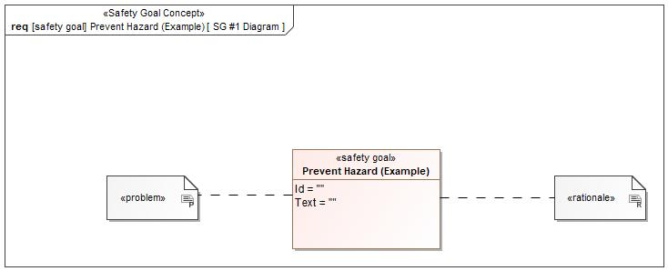

Figure 1: SG #1 Diagram – Prevent Hazard (Example)

*Note: The authoritative source for the Safety Goals is document “FFSD 02 Hazard Analysis* *and Risk Assessment”. The documentation of Safety Goals in this chapter (In the Argumentation for Safety Goal achievement) is for information purposes only.*

*The authoritative source for the Functional Safety Requirements is section 2.1.x.3: of this document. The documentation of Functional Safety Requirements in the following chapter (complete or summarised) is for information purposes only.*

#### Warning and Recovery Concept

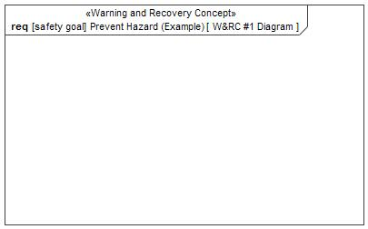

Figure 13: W&RC #1 Diagram – Prevent Hazard (Example)

### Derivation of Functional Safety Requirements on Assumptions

**#Hint:** Derive FSRs from the Assumptions (refer to section “Safety Assumptions”

No Functional Safety Requirements tracing to Assumptions specified.

### ASIL Decomposition of Functional Safety Requirements

***#Hint:*** *For ASIL D features additional measures like a requirements decomposition might be required. Fill out the following table for each ASIL D decomposition applied in the feature.*

*The decomposed FSRs should be listed beneath each table and referenced inside the table by ID and Title*

**#Macro:** [Add Ins -> Add Requirement macro](https://wiki.ford.com/pages/viewpage.action?pageId=174654231) (select “**Func./Tech. Safety Requirement**” as type)

***#Link:***[*Functional Safety Sharepoint*](https://azureford.sharepoint.com/sites/GlobalFunctionalSafety/Pages/default.aspx) *- Functional Safety Concept*

#### Decomposition of Functional Safety Requirement

| Input FSR | First FSR | |
| --- | --- | --- |
| Decomposition Rationale |  | |
| Method for Decomposition | A -> A(A) + QM(A) | |
| FSR 1 after Decomposition | FSR ID |  |
| FSR Title | Monitor Function FSR |
| ASIL | A(A) |
| Rationale |  |
| Satisfied by |  |
| FSR 2 after Decomposition | FSR ID |  |
| FSR Title | Main Function FSR |
| ASIL | QM(A) |
| Rationale |  |
| Satisfied by |  |
| FSR for Independence  *Note: should consider commonly used input, output and processing*  *Note: additional row should be added if additional* *requirements for Independence are necessary* | F-S-Req.-ID |  |
| F-S-Req. Title | Main and Monitor Independence |
| ASIL |  |
| Rationale |  |

# CyberSecurity

**#Classification**: Cybersecurity only – leave a statement “Not Applicable” otherwise and remove subchapters.

## Security Goals

**#Hint:** The list of Cybersecurity Goals are an output of the Threat Model. The CAL attribute is not used yet.

**#Link:** [Alignment with Cybersecurity](http://wiki.ford.com/display/RequirementsEngineering/Alignment+with+Cybersecurity) – RE Wiki

|  |  |
| --- | --- |
| ID | Goal |

Table 16: Cybersecurity Goals

## Cybersecurity Requirements

**#Hint:** Cybersecurity requirements derived from the Cybersecurity Goals. Those requirements should be granular enough to be satisfied by a single Logical Function in the Functional Architecture.

**#Link:** [Alignment with Cybersecurity](http://wiki.ford.com/display/RequirementsEngineering/Alignment+with+Cybersecurity) – RE Wiki

**#Macro:** [Add Ins -> Add Requirement macro](https://wiki.ford.com/pages/viewpage.action?pageId=174654231) (select “**Requirement**” as type)

# Architecture

## Functional Decomposition

**#Hint:** Techniques like Activity Diagrams, Data Flow or Function Tree Diagrams help the feature owner to analyze the behavior of the feature. The goal of functional decomposition is to gain a complete understanding of the desired functionality, independent of technological solutions. The Feature Owner may group the requirements in chapter “Feature Requirements” according to the functions derived from this decomposition. The Feature Owner may take the Functional Architecture for related features (if it exists) into consideration for this decomposition. This would ease cascading of feature requirements later on. Since feature requirements are input requirements for the Logical Functions, it helps, if the feature requirements are grouped by functions when cascaded to Logical Functions of the Functional Architecture.

**#Link:**

* [Stages - RE Model the Functional Analysis](https://bd101001.pd2.ford.com/stages/#/workspace/209/_vv/(process/activity/_4KsyQPmOkqGMg85u0m-tig))
* [SysML – Activity Diagrams](https://azureford.sharepoint.com/sites/SystemsEngineering/SEC/sysml-teamsite/SysML%20Wiki/Activity%20Diagram%20Basics.aspx)

Description of the diagram and content about Functional Architecture in Documentation field of Functional Boundary Diagram.



Figure 14: Functional Boundary Behavior

### Functions

**#Hint:** The functions derived by functional decomposition should be listed and described in the table below

| **Function Name** | Description | Comments |
| --- | --- | --- |
| *(activity)* Open doors for Deploy | *(activity)* The Running Board will be deploy when the Customer Open the Door. |  |
| *(activity)* Deploy Running Boards | *(activity)* PRB will be deployed |  |
| *(activity)* Nochange_Deploy | *(activity)* Already PRB status is deployed, If the customer unlock the vehicle but the vehicle will not any change |  |
| *(activity)* PRB Auto mode | *(activity)* PRB mode is Auto |  |
| *(activity)* PRB Out mode | *(activity)* PRB mode is Out |  |
| *(activity)* PRB Deploy | *(activity)* User gives the Command for PRB Deploy |  |
| *(activity)* Close Doors for Stow | *(activity)* The Customer close the door. The PRB will be Stowed |  |
| *(activity)* Activate the FOB Key | *(activity)* If the user approaches to the vehicle with Key FOB, then the FOB Key is activated |  |
| *(activity)* Stow Running Boards | *(activity)* PRB will be stowed |  |
| *(activity)* PRB Stow | *(activity)* User gives the Command for PRB Stow |  |
| *(activity)* NoChange_Stow | *(activity)* Already PRB status is stowed, If the customer unlock the vehicle or when the customer leaves the vehicle with the key FOB but the vehicle will not any change |  |
| *(activity)* Door Locks | *(activity)* The Vehicle will be locked and stows the Running Boards. |  |
| *(activity)* PRB Off Mode | *(activity)* PRB mode is Off |  |
| *(activity)* PRB Approach for Deploy | *(activity)* The Running Board will be deployed when the Customer approaches the vehicle with the Key FOB |  |
| *(activity)* Activate the KickSwitch for Stow | *(activity)* The Customer activate the PRB using the kick switch system for Stow |  |
| *(activity)* Unlocks with KeyFOB for Deploy | *(activity)* The Customer press Unlock button in the key FOB. PRB will be deployed |  |
| *(activity)* KickSwitch for Stow | *(activity)* The Running Board will be stow when the Customer kicks the kick switch system. |  |
| *(activity)* Door Unlocks | *(activity)* The Vehicle will be unlocked and deploys the Running Boards. |  |
| *(activity)* KickSwitch for Deploy | *(activity)* The Running Board will be deploy when the Customer kicks the kick switch system. |  |
| *(activity)* Activate the KickSwitch for Deploy | *(activity)* The Customer activate the PRB using the kick switch system for deploy |  |
| *(activity)* Lock with KeyFOB for Stow | *(activity)* The Customer press Lock button in the key FOB. PRB will be Stowed |  |
| *(activity)* Vehicle speed >Max Permissible Speed | *(activity)* Vehicle speed >=Max Permissible Speed. Max Permissible Speed value is 5. |  |

Table 17: List of Functions

## Logical Architecture

**#Classification:** Functional Safety only

**#Hint:** Describe (or reference):

* the logical boundary (if known)
* the elements/components/subsystems within the boundary of the item/feature.
* The interaction of features with other features or elements

The logical boundary of the item/feature can be described by using a boundary diagram, block diagram, etc. The elements of the feature can also be based on other technology.

**#Link:** [Ford Functional Safety Sharepoint](https://azureford.sharepoint.com/sites/GlobalFunctionalSafety/Pages/default.aspx)

Description of diagram and content on logical architecture in Documentation field of Structural Boundary Diagram.

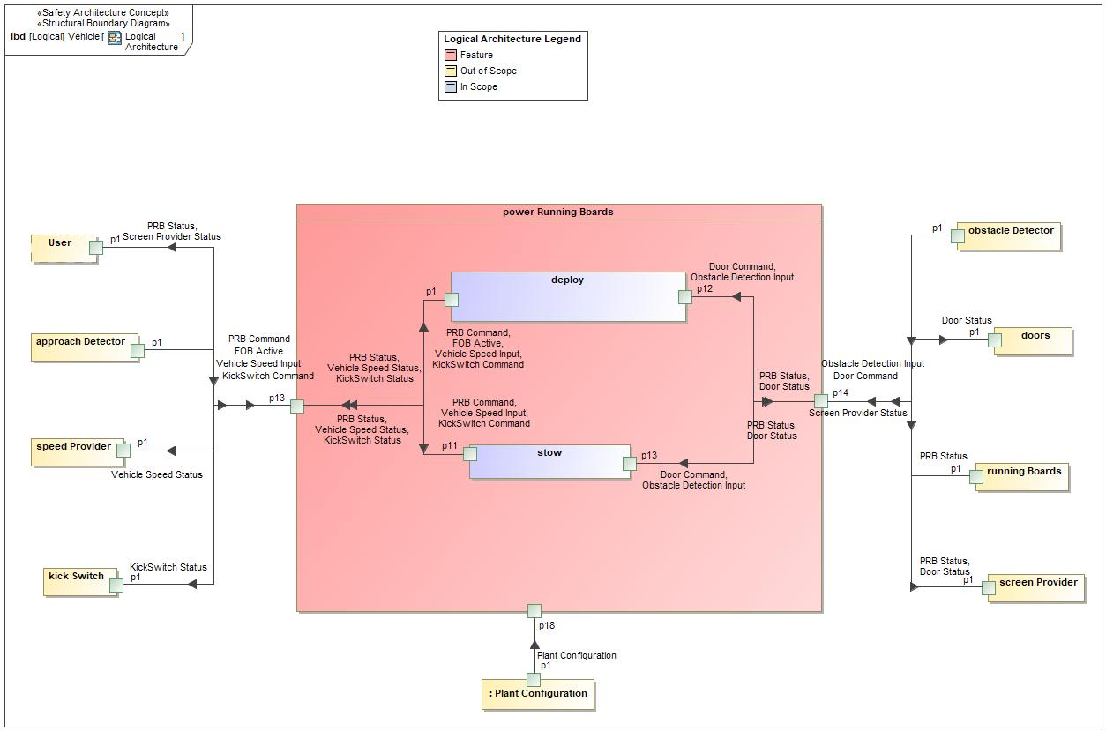

Figure 15: Logical

Architecture

### Logical Elements

**#Hint:** Lists the elements of the Logical Architecture and the functions from the Functional Architecture, which are allocated to those elements.

| **Element Name** | **Description** | **Allocated Functions** | **Comments** |
| --- | --- | --- | --- |
|  |  |  |  |
| Approach Detector | Key Fob will deploy or Stow the Running board when reach Approach Detector Zone | * Activate the FOB Key * PRB Approach for Deploy |  |
| Deploy | When the running board is deployed, both running boards are extended away from the body of the  vehicle and the step surface is accessible. | * Unlocks with KeyFOB for Deploy * PRB Deploy * Nochange_Deploy * KickSwitch for Deploy * Activate the KickSwitch for Deploy * Deploy Running Boards * Open doors for Deploy * PRB Approach for Deploy * PRB Auto mode * PRB Out mode |  |
| Doors | It provides the door status | * Close Doors for Stow * Door Locks * Door Unlocks * Open doors for Deploy |  |
| Kick Switch | The Kick switch is a switch located at the rear side of each running board. When the customer depresses  the Kick Switch, it will deploy or stow the running boards | * Activate the KickSwitch for Deploy * Activate the KickSwitch for Stow * KickSwitch for Deploy * Lock with KeyFOB for Stow * KickSwitch for Stow |  |
| Obstacle Detector | While moving in either to stow or deploy direction, the PRBs feature monitors the system movement to determine when an obstacle is encountered before exerting an unsafe squeeze force |  |  |
| Plant Configuration | Plant Configuration |  |  |
| Power Running Boards | Power Running Boards feature | * Stow Running Boards * Deploy Running Boards |  |
| Running Boards | It provides the running board status | * Deploy Running Boards * Stow Running Boards |  |
| Screen Provider | Provides the Screen Status |  |  |
| Speed Provider | Provides the Vehicle Speed | * Vehicle speed >Max Permissible Speed |  |
| Stow | When the running board is stowed, both PRBs are tucked close to the body of the vehicle and the  step surface is NOT accessible. | * Stow Running Boards * KickSwitch for Stow * PRB Stow * NoChange_Stow * Lock with KeyFOB for Stow * Close Doors for Stow * Activate the KickSwitch for Stow * PRB Auto mode * PRB Off Mode |  |
| User | User operates the PRB Feature |  |  |

Table 18: Logical Elements

### Logical Interfaces

**#Hint:** Describe the interactions of the feature with other features or elements.

| **Interface** | **Direction** | **Description** | **Value Range** |
| --- | --- | --- | --- |
| Door Command | p1 (Doors) To p14 (Power Running Boards) | It shows the command of Door. |  |
| p14 (Power Running Boards) To p12 (Deploy) | It shows the command of Door. |  |
| p14 (Power Running Boards) To p13 (Stow) | It shows the command of Door. |  |
| Door Status | p12 (Deploy) To p14 (Power Running Boards) | It provides the status of Door. |  |
| p13 (Stow) To p14 (Power Running Boards) | It provides the status of Door. |  |
| p14 (Power Running Boards) To p1 (Doors) | It provides the status of Door. |  |
| p14 (Power Running Boards) To p1 (Screen Provider) | It provides the status of Door. |  |
| FOB Active | p1 (Approach Detector) To p13 (Power Running Boards) | It provides the FOB status |  |
| p13 (Power Running Boards) To p1 (Deploy) | It provides the FOB status |  |
| p13 (Power Running Boards) To p11 (Stow) | It provides the FOB status |  |
| KickSwitch Command | p1 (Kick Switch) To p13 (Power Running Boards) | It shows the command of kickswitch |  |
| p13 (Power Running Boards) To p1 (Deploy) | It shows the command of kickswitch |  |
| p13 (Power Running Boards) To p11 (Stow) | It shows the command of kickswitch |  |
| KickSwitch Status | p1 (Deploy) To p13 (Power Running Boards) | It provides the KickSwitch status |  |
| p11 (Stow) To p13 (Power Running Boards) | It provides the KickSwitch status |  |
| p13 (Power Running Boards) To p1 (Kick Switch) | It provides the KickSwitch status |  |
| Obstacle Detection Input | p1 (Obstacle Detector) To p14 (Power Running Boards) | It provides the Obstacle Detection input |  |
| p14 (Power Running Boards) To p12 (Deploy) | It provides the Obstacle Detection input |  |
| p14 (Power Running Boards) To p13 (Stow) | It provides the Obstacle Detection input |  |
| Plant Configuration | p1 (Plant Configuration) To p18 (Power Running Boards) | Plant Configuration |  |
| PRB Command | p1 (User) To p13 (Power Running Boards) | User gives the Command for PRB Deploy or PRB Stow |  |
| p13 (Power Running Boards) To p1 (Deploy) | User gives the Command for PRB Deploy or PRB Stow |  |
| p13 (Power Running Boards) To p11 (Stow) | User gives the Command for PRB Deploy or PRB Stow |  |
| PRB Status | p1 (Deploy) To p13 (Power Running Boards) | It provides the status of PRB |  |
| p1 (Running Boards) To p14 (Power Running Boards) | It provides the status of PRB |  |
| p11 (Stow) To p13 (Power Running Boards) | It provides the status of PRB |  |
| p12 (Deploy) To p14 (Power Running Boards) | It provides the status of PRB |  |
| p13 (Power Running Boards) To p1 (User) | It provides the status of PRB |  |
| p13 (Stow) To p14 (Power Running Boards) | It provides the status of PRB |  |
| p14 (Power Running Boards) To p1 (Running Boards) | It provides the status of PRB |  |
| p14 (Power Running Boards) To p1 (Screen Provider) | It provides the status of PRB |  |
| p14 (Power Running Boards) To p12 (Deploy) | It provides the status of PRB |  |
| Screen Provider Status | p1 (Screen Provider) To p14 (Power Running Boards) | It Provides the Status of Screen |  |
| p13 (Power Running Boards) To p1 (User) | It Provides the Status of Screen |  |
| p14 (Power Running Boards) To p12 (Deploy) | It Provides the Status of Screen |  |
| p14 (Power Running Boards) To p13 (Stow) | It Provides the Status of Screen |  |
| Vehicle Speed Input | p1 (Speed Provider) To p13 (Power Running Boards) | It Provides the Vehicle Speed input |  |
| p13 (Power Running Boards) To p1 (Deploy) | It Provides the Vehicle Speed input |  |
| p13 (Power Running Boards) To p11 (Stow) | It Provides the Vehicle Speed input |  |
| Vehicle Speed Status | p1 (Deploy) To p13 (Power Running Boards) | It Provides the Status of Vehicle Speed |  |
| p1 (Running Boards) To p14 (Power Running Boards) | It Provides the Status of Vehicle Speed |  |
| p11 (Stow) To p13 (Power Running Boards) | It Provides the Status of Vehicle Speed |  |
| p13 (Power Running Boards) To p1 (Speed Provider) | It Provides the Status of Vehicle Speed |  |
| p14 (Power Running Boards) To p13 (Stow) | It Provides the Status of Vehicle Speed |  |

Table 19: Feature Interactions

# Traceability Matrix

**#Hint:** The traceability matrix is ideally generated from a Requirement Management tool (e.g. VSEM RM) once the specification is imported to the tool and all trace links are drawn in the tool.

**#Link:** Refer to “Backward Traceability” at [Stages – RE Traceabilty Record](https://bd101001.pd2.ford.com/stages/#/workspace/209/_vv/(process/artifact/_ZbIhsK4EkzaN49uPh7SLuQ))

# Open Concerns

**#Hint:** The following list presents open concerns, which have to be discussed or clarified over the course of the on-going requirements engineering.

| ID | Concern Description | e-Tracker / Reference | Responsible | Status | Solution |
| --- | --- | --- | --- | --- | --- |
| 1 |  |  |  |  |  |

Table 20: Open Concerns *(Not supported by MagicDraw report generation)*

# Revision History

**#Hint:** A new version number is assigned to a document with a given revision each time it is checked in to Team Center (TCSE). After release of a revision, the document cannot be edited and no new versions can be created on that revision. When updating the document after that, a new revision has to be created and new versions on that revision will be created upon checking in.

No Revision History found.

## Template Revisions

*#Important: Do not change this section*

|  |  |  |  |  |
| --- | --- | --- | --- | --- |
| Version | Rev. | Date | Description | Responsible |
| 0 | 6 | 2015-05-26 | * Chapter “Feature Overview” and made a 2nd level heading. * Chapter “Feature Modeling” divided into 3 subchapter (“Scenarios”, “Use Cases”, “State Machines”) for different modeling methods | Jbaden1 |
| 0 | 7 | 2015-05-27 | * Table of Content updated * Template Revision History chapter added | Jbaden1 |
| 0 | 8 | 2015-07-02 | * Section “Unsettled Issues” added | Alevin7 |
| 0 | 9 | 2015-08-04 | * Section “Feature Variants” added * Section “Feature Boundary Diagram” renamed to “Feature Context Diagram” * Document Properties adapted to match needs of VBA macros | Jbaden1, Awegman1 |
| 1 | 0 | 2015-09-11 | * Section “Feature Variants” reworked * Feature Goals removed. Only “Safety Goals“ chapter remains. * Heading 2 formatting issues corrected. * Requirements / Use Cases Listing removed from traceability chapter. * Formatting of attribute table in Notation chapter corrected * Open Topics / Known Issues chapter moved to the end | Jbaden1 |
| 1 | 1 | 2015-11-16 | * Table-Styles removed (for smooth VSEM import) * Some clean-up of sections “Purpose” and “Audience” | Awegman1, jbaden1 |
| 1 | 2 | 2016-02-26 | * Minor corrections based on lessons learned from CC and PCL pilot (e.g. section market/regions) and discussion with Functional Safety Team (purpose of feature) * Footer corrected * Boundary diagram interface chapter renamed to influences. | Jbaden1 |
| 1 | 3 | 2016-02-26 | * Minor corrections after review with Whitney Keith from Functional Safety team | Jbaden1 |
| 1 | 4 | 2016-03-10 | * Some cleanup of meta-data in Word Properties | Jbaden1 |
| 1 | 5 | 2016-03-10 | * Footer formatting corrected (Issue 19) * Results from review with Functional Safety Team incorporated (Issue 20). | jbaden1 |
| 1 | 6 | 2016-04-18 | * Scenario Template added | Jbaden1 |
| 1 | 7 | 2016-04-18 | * Chapter “Operation Modes and States” moved before “Use Case” section. | Jbaden1 |
| 1 | 8 | 2016-04-18 | * Broken Wiki links repaired. | Jbaden1 |
| 2 | 0 | 2016-05-19 | * Adapted to Specification_Macros.dotm V2.0 * Requirements Templates chapter (ch. 1.7.1) no longer has an attribute table, but refers directly to the Wiki.. | Jbaden1 |
| 2 | 1 | 2016-06-10 | * Table for Context Diagram modified (lists external entities and Influence Description only) | Jbaden1 |
| 2 | 2 | 2016-07-08 | * Template version added to footer * Several hints added to the various sections * Findings from Functional Safety Team incorporated. * RE_SafetyRequirement style added | Jbaden1 |
| 2 | 3 | 2016-09-21 | * Update from Functional Safety Team incorporated (“Lessons Learned”, “System Behaviors for HARA”) | Jbaden1 |
| 2 | 4 | 2016-11-15 | * Update from Functional Safety Team incorporated (“Lessons Learned”, “System Behaviors for HARA”) * Explanatory notes made more formal | Jbaden1 |
| 3 |  |  | Skipped to synchronize with Specification_Macros.dotm |  |
| 4 |  |
| 5 | 0 | 2017-01-13 | * Meta data updated for specification macros, version 3.1 * SW Unit chapter removed for the time being * Green boxes added for user hints | Jbaden1 |
| 5 | 1 | 2017-01-18 | * Minor editorial changes | Jbaden1 |
| 6 | 0 | 2017-02-03 | * CR48: Chapter 6 renamed from “Safety” to “Functional Safety”. New sub-chapter “Safety” introduced in Non-Functional Requirements section | Jbaden1 |
| 6 | 0 | 2017-04-28 | * CR7: “RequirementsTraceability” chapter removed | Jbaden1 |
| 6 | 0 | 2017-11-15 | * CR32/53: New Cover Sheet + Disclaimer replaces FAP-150 like ones. * CR75: Some rewording -> Terminology to Glossary, Notation -> Document Conventions * CR49: Rename “Assumptions & Constraints” to “Assumptions” * CR74: Safety Assumptions added to chapter 6. * CR58: Add function allocation column to Logical Architecture chapter | Jbaden1 |
| 6 | 0 | 2018-01-31 | * CR63: Updated links to Functional Safety Sharepoint | Jbaden1 |
| 6 | 0 | 2018-07-24 | * CR69: Add FSR to FeatureDoc * CR64: Add new section "Design Requirements" to Function Spec and Feature Spec | Jbaden1 |
| 6 | 0 | 2018-08-06 | * CR53: some corrections for metada and formatting | Jbaden1 |
| 6 | 0 | 2018-09-28 | * Broken links to RE Wiki repaired | Jbaden1 |
| 6 | 0 | 2018-10-31 | * Cover sheet and footer more GIS like. Functional Safety team feedback incorporated:   + New subsections “Functional Safety Requirements, (Decomposed) FSRs and Parameters / Values   + Removal of “Logical Architecture” | Jbaden1 |
| 6 | 0 | 2018-12-12 | * FSR template removed, now as a macro in the Specification_Macros.dotm | Jbaden1 |
| 6 | 0a | 2019-05-23 | * Re-introduce “Logical Architecture” (for Functional Safety) | Jbaden1 |
| 6 | 0b | 2019-06-26 | * Chapter “Logical Elements” in “Logical Architecture” section added (FuSa CR 15136240) | Jbaden1 |
| 6 | 0c | 2019-03-22 | * Chapter “Decomposed FSRs” renamed to “ASIL Decomposition of Functional Safety Requirements” and moved beneath Chapter “Functional Safety Requirements”. Explanatory text improved. | Jbaden1 |
| 6 | 0c | 2019-04-05 | * Some wording in ASIL decomposition table modified. Description of fields in that table improved. | Jbaden1 |
| 6 | 0c | 2019-06-24 | * “Input Requirements” section modified (table approach as for the other RE templates). * “References” and “Glossary” chapter moved to the “Introduction” chapter. | Jbaden1 |
| 6 | 0c | 2019-07-02 | * "Important" box added on cover sheet which points to the macros | Jbaden1 |
| 6 | 0c | 2019-07-02 | * Subsection “Error Handling” removed form chapter “Feature Requirements”->”Functional Requirements” (teams are free to create their own substructure of that section). Note tells author not to forget about error handling. * Hint for chapter “Feature Variants” improved reworded upon request from Functional Safety Team. | Jbaden1 |
| 6 | 0c | 2019-05-11 | * Copyright notice shortened and moved to cover sheet and added to footer (to be compliant [with Ford copyright guidelines](http://www.fgti.ford.com/client/NewFGTI/CopyrightNotice.html)) * Term “Disclaimer” no longer used for what is actually only a copyright notice | Jbaden1 |
| 6 | 0c | 2019-22-11 | * Chapter “Input Requirements/Documentst: minor modifications (examples added), Word comment removed” | Jbaden1 |
| 6 | 0c | 2019-12-05 | * Upstream Documents section added to “Input Requirements/Documents” table * Custom style table formatting removed * Hint on system behaviors modified as requested from FuSa team | Jbaden1 |
| 6 | 0c | 2019-12-09 | * Term “Upstream Documents” replaced by “Attribute Requirements” in “Input Requirements/Documents” table * ASIL Decomposition table replaced by a version, which get not corrupted during VSEM import. | Jbaden1 |
| 6 | 0c | 2019-12-10 | * In ch. “Functional Safety Requirements” Word reference Id by Word reference text replaced.. | Jbaden1 |
| 6 | 1a | 2020-02-12 | * New chapter “Cybersecurity” added. | Jbaden1 |
| 6 | 1a | 2020-03-03 | * All User Hints formatted using style “RE_UserHint” to enable automatic removal by a macro. | Jbaden1 |
| 6 | 1a | 2020-03-04 | * Chapter “Cloud Connectivity Data Analytics Requirements” added upon request by D. Crockett/J. Rawlings | Jbaden1 |
| 6 | 1a | 2020-03-09 | * Missing doc property “LatestSigMappingID” and “LatestAisInterfaceID” added * doc property “CopyrightDate” re-formatted to text and copyright date field in footer corrected * Version numbering re-initialized as 0.1 * Init value of version/revision date set to “yyyy/mm/dd” instead of “yyyy-mm-dd” to be in line with the “Edit Document Property” dialog * type of document property for latest IDs changed to number instead of text | Jbaden1 |
| 6 | 1b | 2020-03-17 | * Chapter “Functional Architecture” renamed to “Functional Decomposition” * New MBSE terminology introduced: “Feature Level”, “Function Level” and “Component Level” renamed to “Concept Level”, “Logical Level” and “Technology Level” | Jbaden1 |
| 6 | 1b | 2020-07-03 | * CR31: Chapter “Traceability Matrix” added. | Jbaden1 |
| 6 | 1b | 2020-23-09 | * CR28: Alignment to [*FFSG01.10 Feature Document Guideline*](https://azureford.sharepoint.com/sites/GlobalFunctionalSafety/Released%20Templates%20Guidelines%20and%20Examples/Guidelines/FFSG01.10_FeatureDocument_Guideline.pdf) for how to apply the Feature Doc template for Functional Safety. New section “Classification of Chapters” added. “Active Tilt Control” Example in section “Logical Architecture” updated based on input from HARA training. | Jbaden1 |
| 6 | 1b | 2020-25-11 | * Reference to process definition in Stages added to “How to Use” section on cover sheet. User hints removed from “Document Purpose” chapter. * RE-Wiki links mostly replaced by Stages links, links to Functional Safety Sharepoint updated | Jbaden1 |

# Appendix

## Definitions

| **Definition** | **Description** |
| --- | --- |
| Approach Detection (AD) | Function for Welcome Farewell Feature (Welcome Lights and to Running Board) |
| Approach Detection Zone | When the Key FOB meets the Approach Detection Range |
| Center stack display | Infotainment Display (i.e. SYNC 4) |
| Cycle Time | 1. At a component level, the Running Board Power Mechanism (RBP) must be capable of fully deploying the running board in a maximum of 1.5 seconds.2. At a vehicle level, the system must be capable of deploying the running board in 2.0 seconds from the time an appropriate door is unlatched. 3. At a vehicle level, the RBPM must be capable of fully deploying within 5 seconds at voltages between 11.5Volts and 14.5Volts, and temperature between -30 and -40 degrees C. 4. At a vehicle level, the RBPM must be capable of fully stowing within 5 seconds at voltages between 11.5Volts and 14.5Volts, and temperature between +40 and -40 degrees C. |
| High speed | Approximately more than 52 mph (83 kph) |
| Kick switch | Switch located in the rear side of Running board to deploy or stow the PRB automatically per customer request |
| Low speed | Approximately 12 to 36 mph (19 to 58 kph ) |
| Low speed | Approximately 12 to 36 mph (19 to 58 kph ) |
| Max Motor Current | Maximum motor current cutoff defined before exerting an unsafe squeeze force in order to avoid injuries and/or PRB damages when an obstacle is detected. Variable and configurable by program to be defined in the Functional Specification, proposed is 25 Amp. |
| Max Permissible Speed | Is defined as the Vehicle Speed limit with the PRB deployed, variable and configurable by program to be defined in the functional specification, proposed is >= 5KPH |
| Medium speed | Approximately 36 mph to 52 mph (58 to 83 kph) |
| Obstacle detection | Obstacle obstructing PRB movement detected |
| Pooling Disable time | It’s the time between PK is detected and approach detection is disabled in order to prevent the battery from getting off. Variable and configurable by program to be defined in the Functional Specification, P702 program is 10 Min. |
| term | A representation of a Concept expressed in Natural Language. In the vocabulary of a Domain of Discourse a term enables common understanding of domain concepts. |
| term glossary | A term glossary is a table of agreed upon definitions for terms used in project development that may provide clarity or avoid confusion to stakeholders. |
| Time to stow | Timer used to delay stow operation in AUTO mode after the PRBs are deployed and no doors opened. This variable is configurable by the customer through a SYNC menu, the time is going to be defined by program in the Functional Spec. Proposed time for Pickup is 5 minutes and 25 sec.When a door is opened the time to stow is 3 sec after all doors are closed |
| Very Low Speed | Approximately 0 to 12 mph (0 to 19 kph) |

Table 21: Definitions used in this document

## Abbreviations

| **Abbr.** | **Stands for** |
| --- | --- |
| AD | Approach Detection |
| AD | Approach Detection |
| BCM | Body Control Module |
| BCM | Body Control Module |
| DSM | Driver Seat Module |
| DSM | Driver Seat Module |
| HMI | Human Machine Interface |
| HMI | Human Machine Interface |
| IGN | Ignition |
| IGN | Ignition |
| IPC | Instrument Panel Cluster |
| IPC | Instrument Panel Cluster |
| PK | Passive Key / Key FOB |
| PK | Passive Key / Key FOB |
| PRB | Power Running Board |
| PRB | Power Running Board |
| PWM | Pulse width modulation |
| PWM | Pulse width modulation |
| SDLC | Synchronous Data Link Control |
| SDLC | Synchronous Data Link Control |

Table 22: Abbreviations used in this document

Document ends here.